Tuolumne River Technical Advisory Committee
Don Pedro Project - FERC License 2299

Modesto Irrigation District
Turlock Irrigation District
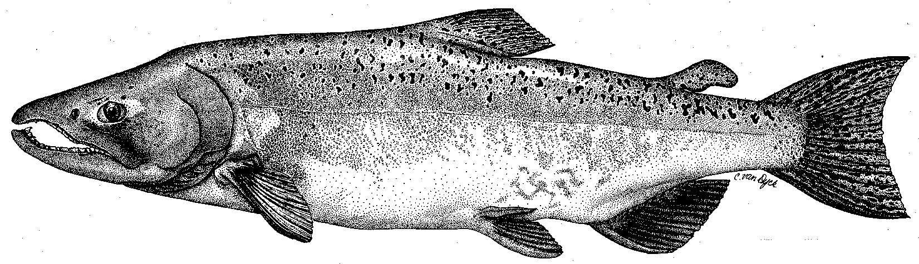

City & County of San Francisco
California Department of Fish & Game
U. S. Fish & Wildlife Service
333 East Canal Drive
Turlock, CA 95381-0949
Phone: (209) 883-8275
Fax: (209) 656-2180

TECHNICAL ADVISORY COMMITTEE MEETING
13 September 2012 at 9:30 AM
Turlock Irrigation District, Room 152

Summary

1. Introduction and Announcements

2. Administrative Items:

Review/Revise agenda – No changes

Approve notes from September meeting – No changes were identified. Notes for the last meeting are posted to the TRTAC website: http://tuolumnerivertac.com/

Items since last meeting – the handout listing the material posted at http://tuolumnerivertac.com/ was reviewed. Those included Agency comments, Draft and Final notes on the Districts’ study workshops for the Hydrology Study (W&AR-2) Workshop and the Salmonid Information Synthesis Study (W&AR-4) workshops 1 and 2. Other correspondences included the Districts filing of July 31st and a subsequent FERC reply of August 17th clarifying requirements of the May 24, 2012 Formal Study Dispute Resolution for the Don Pedro Project. Lastly, CCSF filed two reports with the Commission regarding the effectiveness of any O. mykiss management measures on the lower Tuolumne River that may potentially be adopted as part of the Don Pedro Relicensing.

3. Monitoring/Reports: Handouts were reviewed
- The Final Pulse Flow Study Report was posted to the FERC website on June 18th
- Summer monitoring included routine snorkel surveys in July 2012, additional low-flow IFIM surveys in late June 2012, as well as routine thermograph downloads.
- FERC Relicensing Study activities included accretion flow measurements (W&AR-2), gravel mapping (W&AR-4), predator abundance (W&AR-7), O. mykiss habitat (W&AR-12), as well as riparian habitat mapping (W&AR-19).
- FISHBIO to resume counting weir operations by September 24th

4. Flow Operations:
- Reviewed final SJ Basin Index of 2.1 MAF which corresponds to a Dry Water Year Type with a FERC Flow volume of 127,346 AF.
- Summer flows ranged between 95–115 cfs
- A 3-day pulse flow at 407 cfs is planned for October 11–13, 2012. This will be added to the 150 cfs base flow for a total of 557 cfs for the period. Discussions were underway with USFWS regarding potential date changes to provide coordinated releases with the Merced and Stanislaus Rivers.
5. Agency/NGO updates
- CDFG and USFWS have initiated an adult tracking study using Chinook salmon captured at Jersey Point in the Delta. The study will examine movement and arrival timing of upmigrant spawners in various San Joaquin River basin tributaries as well as temperature exposure history.

6. Additional items
- None.

7. Next mtg dates – Quarterly on 2nd Thursday: December 13, 2012, March 14, 2013

TRTAC Meeting Attendees

Name Organization

- Walter Ward MID (by phone)
- Robert Nees TID
- Steve Boyd TID
- Jason Carkeet TID
- Patrick Maloney TID
- Andrea Fuller FISHBIO
- Noah Hume Stillwater

