Tuolumne River Technical Advisory Committee
Don Pedro Project - FERC License 2299

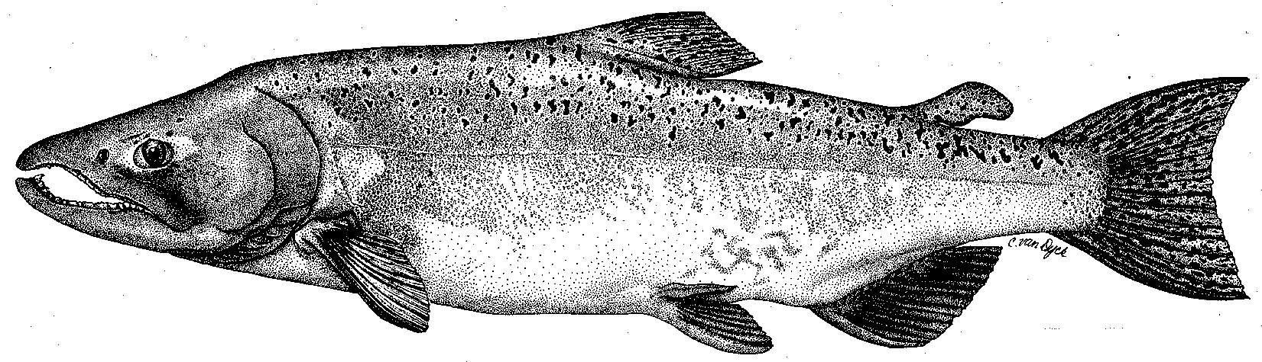

Modesto Irrigation District
Turlock Irrigation District
City & County of San Francisco
California Department of Fish & Game
U. S. Fish & Wildlife Service
333 East Canal Drive
Turlock, CA 95381-0949
Phone: (209) 883-8255
Fax: (209) 656-2180

TECHNICAL ADVISORY COMMITTEE MEETING
13 September 2012 at 9:30 AM
Turlock Irrigation District, Room 152

DRAFT AGENDA

1. Introduction and Announcements

2. Administrative Items:

Review/revise agenda

Approve notes from June 2011 meeting

Items since last meeting

3. Monitoring/Reports:
- Summer 2012 snorkel and temperature monitoring
- Summer 2012 IFIM and HSC data collection
- Summer 2012 surveys for in-progress FERC Relicensing Studies
- Fall monitoring and in-progress FERC studies
- Planned annual FERC report progress
- Annual snorkel report

4. Flow Operations:
- Review status of final basin index, annual fish flow volume, and flow schedule

5. Agency/NGO updates

6. Additional items

7. Next meetings – Quarterly on 2nd Thursday: December 13, 2012; March 8, 2012

