Tuolumne River Technical Advisory Committee
Don Pedro Project - FERC License 2299

Modesto Irrigation District
Turlock Irrigation District
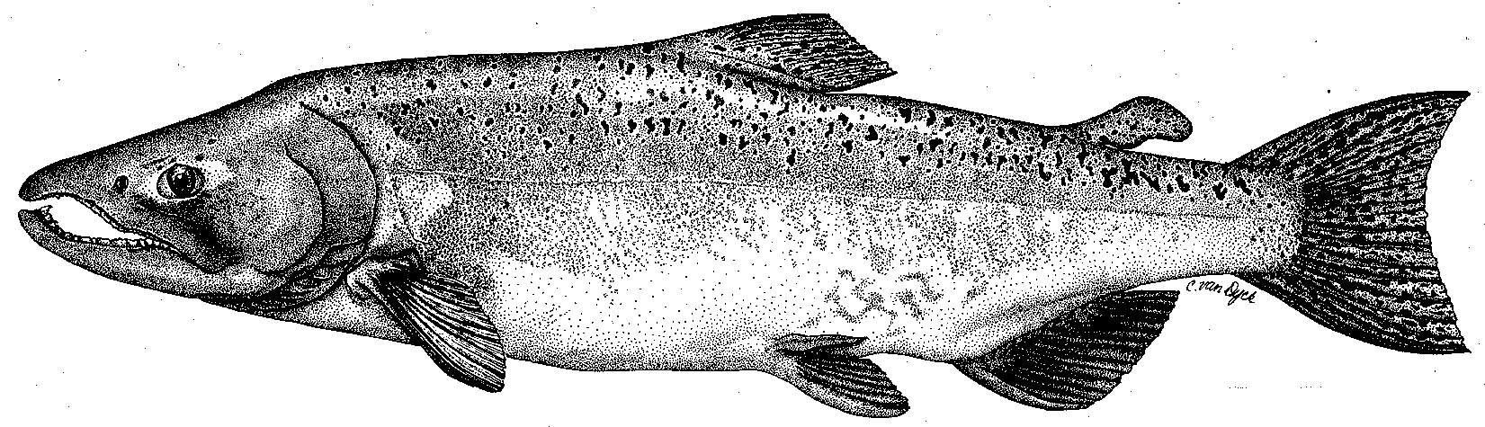

City & County of San Francisco
California Department of Fish & Game
U. S. Fish & Wildlife Service
333 East Canal Drive
Turlock, CA 95381-0949
Phone: (209) 883-8275
Fax: (209) 656-2180

TECHNICAL ADVISORY COMMITTEE MEETING
8 September 2011 at 9:30 AM
Turlock Irrigation District, Room 152

Summary

1. Introduction and Announcements

2. Administrative Items:

Review/Revise agenda – No changes

Approve notes from September meeting – No changes were identified. Notes for the last meeting are posted to the TRTAC website: http://tuolumnerivertac.com/

Items since last meeting – the handout listing the material posted at http://tuolumnerivertac.com/ was reviewed. Those included the Districts’ ILP Proposed Study Plan and FERC Scoping Document No. 2 for the Don Pedro Relicensing, correspondences regarding a flow variance request for the planned low flow surveys as part of the ongoing IFIM studies, IFIM Progress Report No.2, correspondence regarding a schedule extension of the ongoing IFIM studies to April 2013, and updates of the basin monitoring newsletter.

3. Monitoring/Reports: Handouts were reviewed
- Mid-flow IFIM surveys of 600 cfs were completed the week of July 26, 2011
- Planning for low flow IFIM surveys (250 cfs) as well as retrieval of stage recorders for high flow (overbank) surveys were planned for late September.
- FISHBIO to resume counting weir operations by September 16, 2011.

4. Flow Operations:
- Reviewed final SJ Basin Index of 5.1 MAF which corresponds to a Wet Water Year Type with a FERC Flow volume of 300,923 AF. A 5-day pulse flow at 800 cfs is planned for October 10–14, 2011. This will be added to the 300 cfs base flow for a total of 1,100 cfs for the period.
- No summer operations related to temperature control were carried out in 2011 due to high flows and cool air temperatures throughout the Central Valley.

5. Agency/NGO updates
- None

6. Additional items
- None.

7. Next mtg dates – Quarterly on 2nd Thursday: December 8, March 8, 2012

TRTAC Meeting Attendees

Name Organization

- Walter Ward MID
- Robert Nees TID
- Roger Masuda TID
- Noah Hume Stillwater

