Tuolumne River Technical Advisory Committee
Don Pedro Project - FERC License 2299

Modesto Irrigation District
Turlock Irrigation District
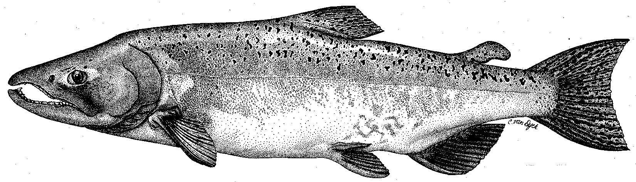

City & County of San Francisco
California Department of Fish & Game
U. S. Fish & Wildlife Service
333 East Canal Drive
Turlock, CA 95381-0949
Phone: (209) 883-8275
Fax: (209) 656-2180

TECHNICAL ADVISORY COMMITTEE MEETING
9 September 2010 at 9:30 AM
Turlock Irrigation District, Lunch Room (2nd floor)

Summary

1. Introduction and Announcements

2. Administrative Items:

Review/Revise agenda – No changes

Approve notes from June meeting – No changes were identified. Notes for the last meeting are posted to the TRTAC website: http://tuolumnerivertac.com/

Items since last meeting – the handout listing the material posted at http://tuolumnerivertac.com/ was reviewed. Those included correspondence regarding the schedules for the IFIM and Water temperature modeling studies included in the May 12, 2010 FERC Order, Draft 2010 Seine report, updated participant list, updates of the basin monitoring newsletter, as well as e-mail correspondences regarding consultation on the planned IFIM study.

3. Monitoring/Reports: Handouts were reviewed
- August reference count and population estimate results: O. mykiss observed from approximately RM 52–39.5 with larger numbers of adult fish than found in the March 2010 surveys or in previous years. A report including both the March 2010 and July 2010 surveys will be done later this year.
- Acoustic tracking Study: Six adult O. mykiss tagged in early 2010 have been tracked using mobile tracking hydrophones, generally remaining within pool habitats in the vicinity of Basso Bridge. 2010–2011 plans include tagging of approximately 20 individuals.
- 2010 Seine report – located on TRTAC website for review.
- Other Summer/Fall monitoring and other study plans: FishBio to resume counting weir operations by September 13, 2010.

4. Flow Operations:
- Reviewed final SJ Basin Index of 3,547,699 AF which corresponds to an Above- Normal Water Year Type with a FERC Flow volume of 300,923 AF. Currently a 6-day pulse flow at 800 cfs is planned for October 1–6, 2010. This will be added to the 300 cfs base flow for a total of 800 cfs for the period. This default schedule will be followed unless the three Agencies come to agreement with the Districts on any recommended changes.
- No summer operations related to temperature control were carried out in 2010 due to high flows and cool air temperatures throughout the Central Valley.

5. Agency/NGO updates
- Tuolumne River Trust to hold annual river cleanup at Legion Park on September 11, 2010
- CDFG expected to expand carcass survey extent downstream of counting weir at RM 24.5

6. Additional items
- None.

7. Next mtg dates – Quarterly on 2nd Thursday: December 9, March 10, 2011

TRTAC Meeting Attendees

Name Organization

- Jason Guignard FishBio
- Andrea Fuller FishBio
- Walter Ward MID
- Robert Nees TID
- Roger Masuda TID
- Noah Hume Stillwater

