Tuolumne River Technical Advisory Committee
Don Pedro Project - FERC License 2299

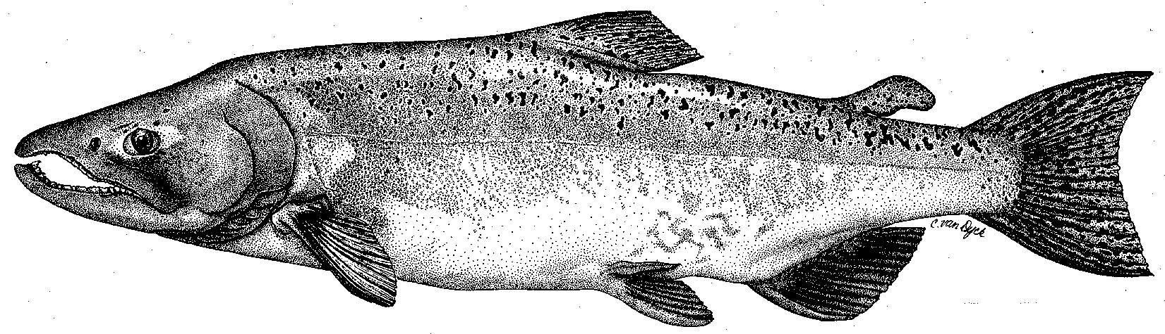

Modesto Irrigation District
Turlock Irrigation District
City & County of San Francisco
California Department of Fish & Game
U. S. Fish & Wildlife Service
333 East Canal Drive
Turlock, CA 95381-0949
Phone: (209) 883-8255
Fax: (209) 656-2180

TECHNICAL ADVISORY COMMITTEE MEETING
9 September 2010 at 9:30 AM
Turlock Irrigation District, Lunch Rm (2nd floor)

DRAFT AGENDA

1. Introduction and Announcements

2. Administrative Items:

Review/revise agenda

Approve notes from June 2010 meeting

Items since last meeting

3. Monitoring/Reports:
- August reference count survey and population estimate surveys
- Posted 2009 seine report
- Discuss fall monitoring and in-progress FERC studies

4. Flow Operations:
- Review status of final basin index, annual fish flow volume, and flow schedule
- Review summer flow operation

5. Agency/NGO updates

6. Additional items

7. Next meetings – Quarterly on 2nd Thursday: December 9; March 10, 2011

