Tuolumne River Technical Advisory Committee
Don Pedro Project - FERC License 2299

Modesto Irrigation District
Turlock Irrigation District
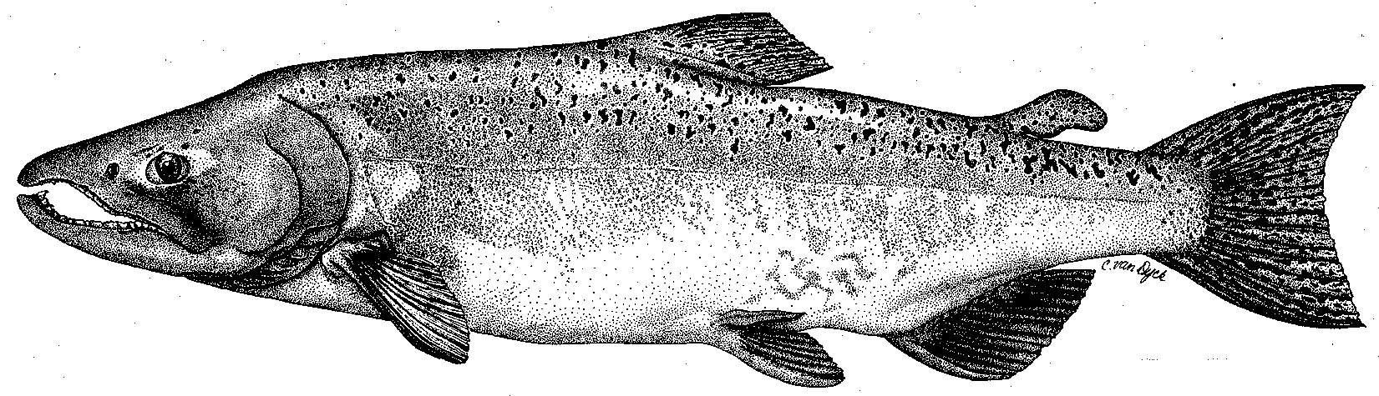

City & County of San Francisco
California Department of Fish & Game
U. S. Fish & Wildlife Service
333 East Canal Drive
Turlock, CA 95381-0949
Phone: (209) 883-8275
Fax: (209) 656-2180
Email: tjford@tid.org

TECHNICAL ADVISORY COMMITTEE MEETING
10 September 2009 at 9:30 AM
Turlock Irrigation District, Lunch Room (2nd floor)

Summary

1. Introduction and Announcements
- See attendee list at end (no fishery agencies were present)

2. Administrative Items:

Review/Revise agenda – No changes

Approve notes from June meeting – No changes were identified. Notes for the last meeting are posted to the TRTAC website: http://tuolumnerivertac.com/

Items since last meeting – the handout listing the material posted at http://tuolumnerivertac.com/ was reviewed. Those included correspondence regarding the potential rehearing on the 2005 10-Year Summary Report, July 15 FERC Order, preliminary Bobcat Flat West Restoration Plans by FOT, a letter from CDFG to FERC regarding fall 2008 water diversion at La Grange Powerhouse, transmittal letter and draft FERC Ordered study plans on Instream Flow and Water Temperature Modeling, draft 2009 seine and snorkel reports, June snorkel, thermograph data through July 20, updates of the basin monitoring newsletter (including RST results), and an updated participant list.

3. Monitoring/Reports:
- June snorkel survey and July population estimate results: Discussed June snorkel survey and preliminary findings of July population survey. O. mykiss were observed from approximately RM 52–42 with greater proportions of adult-sized fish upstream. About 3,480 juvenile and 960 adult O. mykiss were estimated within the study reach, in comparison to 2,470 juveniles and 770 adults in July 2008 (preliminary numbers). A report including both the March 2009 and July 2009 surveys will be done later this year.
- 2009 seine and snorkel reports – located on TRTAC website for review.
- Other Summer/Fall monitoring and other study plans: Thermographs were downloaded through 20Jul2009 and would be downloaded again in early fall. Invertebrate sample collections were completed in July and being analyzed, with report completion in early 2010. Plans to install a counting weir for fall 2009 are pending permit approvals.

4. Flow Operations:
- Reviewed final annual flow volume of 179,581 AF which corresponds to a “Median-Below Normal” Fish Flow Year Type with only a 2–3 day fall pulse planned.
- Ford and Masuda described how the higher “True-Up” volume resulting from the increased final basin index could be allocated in the fall and winter for the first time since 2003.
- Ford reviewed the summer flow operations, which averaged 105 cfs from mid-June through August, and had higher releases with hotter air temperature forecasts.

5. Agency/NGO updates
- ESRCD (East Stanislaus Resource Conservation District)
  - Nolan discussed his salmonid research and work history on North Coast rivers
  - Recently accepted position as watershed coordinator is attending TRTAC and Tuolumne River Coalition (TRC) meetings – would also be involved on Stanislaus River. Roseman indicated the next TRC meeting will be in October.
  - Discussed salmon festival planning at Knights Ferry. Ford suggested reviewing Stanislaus counting weir data for run timing.
- TRT (Tuolumne River Trust)
  - Roseman discussed the local cleanup day planned at Legion Park on Saturday September 12th
  - Roseman discussed plans for the removal of remaining portions of Dennett Dam near the 9th St. Bridge in Modesto. TRT is applying for funding through NOAA Open Rivers initiative and the CDFG Sport Fishing Stamp Program to remove the dam as a migratory barrier (and safety concern). Potential concerns discussed by the group included small changes in the channel profile as well as liability during demolition. He will be requesting support letters for the proposal.

6. Additional items
- None.

7. Next mtg dates – Quarterly on 2nd Thursday: December 10, March 11

TRTAC Meeting Attendees

Name Organization

- Greg Deas (Phone) MID
- Tim Ford TID/MID
- Noah Hume Stillwater
- Roger Masuda TID
- Galileo Morales TID
- Jesse Nolan East Stanislaus RCD
- Jesse Roseman Tuolumne River Trust
- Bill Sears SFPUC

