Tuolumne River Technical Advisory Committee
Don Pedro Project - FERC License 2299

Modesto Irrigation District
Turlock Irrigation District
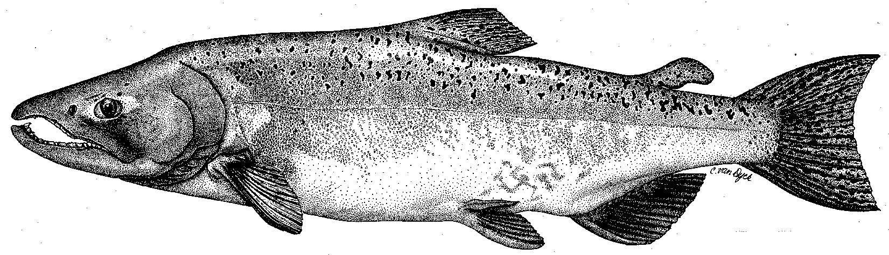

City & County of San Francisco
California Department of Fish & Game
U. S. Fish & Wildlife Service
333 East Canal Drive
Turlock, CA 95381-0949
Phone: (209) 883-8275
Fax: (209) 656-2180
Email: tjford@tid.org

TECHNICAL ADVISORY COMMITTEE MEETING
11 September 2008 at 9:30 AM
Turlock Irrigation District, Lunch Room (2nd floor)

Summary

1. Introduction and Announcements
- No fishery agencies were present.
- Boucher noted that Mesick is expected to be leaving USFWS by 28 September and will be replaced by Zachary Jackson and Kim Webb.

2. Administrative Items:

Review/revise agenda – no changes

Approve notes from June 12, 2008 meeting – One typo to correct on p. 3, under AFRP Grant discussion, FOT contribution should be $175K – summary was approved.

Items since last meeting – reviewed handout listing the material posted at http://tuolumnerivertac.com/

3. Monitoring:
- June snorkel survey and July population estimate survey
    - Discussed June snorkel survey – results had been posted
    - Preliminary findings of July population survey: O. mykiss were observed from approximately RM 52–41 with greater proportions of larger fish upstream. Hume stated initial estimates on “adults” are in 100’s and juveniles were in 1000’s. Boucher noted that it would be valuable to conduct these studies during wetter year types as well as the current conditions. Some discussion regarding adult Chinook observations upstream as well as adult striped bass reported being caught near Basso Bridge.
- Discuss other trout studies
    - Planning for anadromy and tracking studies. Study plan description and commentary solicited from fishery agencies in letter of 26 August.
- Results of May assessment of Peaslee Creek sediment in river expected in October. Boucher noted that much of the fine sediment appears to have infiltrated or been washed out. No invertebrate data summary available yet.

4. Flow Operations:
- Reviewed final basin index of 121,838 AF which corresponds to an Intermediate Critical-Dry Water Year Type. Only a small 2-day fall pulse at about 250 cfs using remainder of interpolation water.
- Boucher discussed the flow schedule determination process and suggested that the Fish Flow Appendix from the Ten Year Summary Report be posted on the TRTAC website: http://tuolumnerivertac.com/ [the appendices are posted]

5. Restoration :
- No changes from June 12 Update by Wilton Fryer.
- Proposal was submitted by FOT for ESRCD to administer $400k SFPUC funding for additional gravel augmentation at Bobcat Flat. Districts will consider a larger proposal for other gravel additions. Boucher noted that other agencies will be reviewing the proposals for the ESRCD
- DFG has not provided CALFED funds for TRTAC projects: Gravel Addition Project (about $3.9 million) and Mining Reach Project (about $10.8 million). Discussion to pursue currently stalled gravel addition funding through the CBDA Amendment Committee.
- Ford and Boucher discussed general areas for priority gravel implementation should funding be made available.

6. Agency/NGO updates
- FOT
  - Discussion of lot line adjustment and 34-acre land purchase in Bobcat Flat area using earlier CCSF funds through ESRCD; survey monuments needed
  - AFRP Grant funding to FOT for Bobcat Flat gravel addition was for $100k.

7. Additional items
- Infiltration Gallery Project decision expected by early next year.
- VAMP study summary report expected by late October – peer review to follow.
- Boucher suggested pursuing changes to the local fishing regulations to protect native fish by reducing or eliminating salmon allowance and relaxing limits on bass and non-native species.

8. Next meeting dates – Quarterly on 2nd Thursday: December 11, March 12, 2009

TRTAC Meeting Attendees

Name Organization

- Tim Ford TID/MID
- Robert Nees TID
- Roger Masuda TID
- Walter Ward MID
- Ron Yoshiyama CCSF
- Noah Hume Stillwater Sciences
- Allison Boucher Friends of the Tuolumne

