Tuolumne River Technical Advisory Committee
Don Pedro Project - FERC License 2299

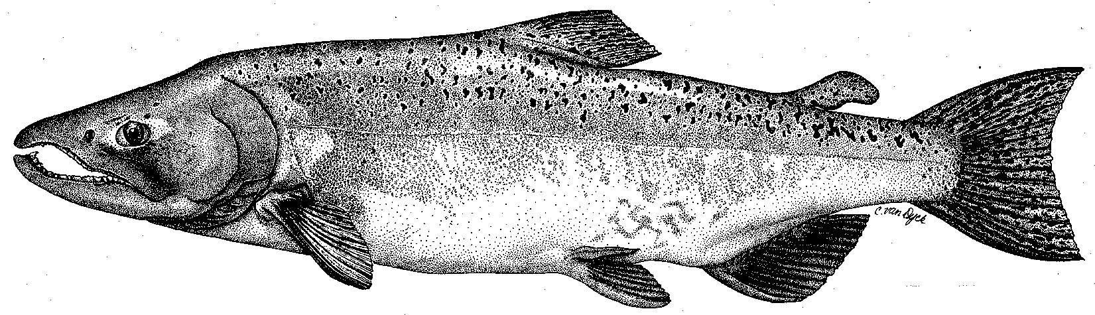

Modesto Irrigation District
Turlock Irrigation District
City & County of San Francisco
California Department of Fish & Game
U. S. Fish & Wildlife Service
333 East Canal Drive
Turlock, CA 95381-0949
Phone: (209) 883-8275
Fax: (209) 656-2180
Email: tjford@tid.org

TECHNICAL ADVISORY COMMITTEE MEETING

13 September 2007
9:30 AM
Turlock Irrigation District, Lunch Room (2nd floor)

Final Summary

1. Introduction and comments on draft agenda
- DFG would not be attending per message to Wilton Fryer/TID
- Cindy Charles of Golden West Women Flyfishers (GWWF) was attending for the first time
- Flow schedule review would be first update topic discussed

2. Items since June 2007 meeting

Comments on material list – the items listed since June were reviewed (meetings, correspondence, documents, data, participant list) – all available at website

3. General Updates

Data and report status

2007 Screw trap data report has been posted

Snorkel and thermograph data has been posted

- Agency and NGO updates
  - GWWF – Members fish the Tuolumne and are interested in summer temperature conditions for trout; further review of recent data should be made

- Monitoring update
- Another snorkel survey will be done later in the month
- Invertebrate sampling was done in late July

- Restoration update
  - Handout of updated TRTAC project status from Fryer (TID) was reviewed:
    - Gasburg Project to be completed by December, but CDFG has IDed some issues about prior work
    - Gravel addition project: the amendment is now waiting for a new CDFG evaluation report to be completed by the end of the year. Even if approved, that could cause more delay of another year to 2009
    - Warner-Deardorff and Ruddy Reach channel restoration projects are also stalled until the new CDFG evaluation report

4. River operations and forecasts – Flow schedule

Current schedule went from 95 cfs to 76 cfs on 11 September to adjust to final volume; another schedule letter was sent out

Ford provided a PowerPoint/handout review of flow schedule determination process

Dry years under current system since 1995 were 2001-2004 and 2007 (driest)

Year types, volumes, and seasonal allocations, including scheduling of interpolation volumes, were reviewed

Review of basin index forecasts (50% and 90%) and schedule volume changes over time was done for 2004 and 2007

Changes in the 2007 50% and 90% volumes relative to schedule year types were reviewed

Examples of other dry year fall flow schedules were provided; NMFS is coordinating with other agencies regarding if a fall pulse flow allocation is recommended

5. Additional items
- Question from Burmester of pulse flow effects on low DO conditions at Stockton in the Deep Water Ship Channel; Hume thought about 2,000 cfs at Vernalis would increase DO; it was noted that some salmon seemed to even get past low DO, perhaps by another migration route, such as Old River before barrier placement.

6. Next meetings and topics
- 13 December, starting at 9:30 AM at TID

FERC 2299 TRTAC Meeting

13 September 2007

Name Organization

Tim Ford TID/MID
Robert Nees TID
Roger Masuda TID
Wes Monier TID
Debbie Liebersbach TID
Walter Ward MID
Bill Sears CCSF
Ron Yoshiyama CCSF
Rick Burmester USFWS
Noah Hume Stillwater Sciences
Cindy Charles Golden West Women Flyfishers

