Tuolumne River Technical Advisory Committee
Don Pedro Project - FERC License 2299

Modesto Irrigation District
Turlock Irrigation District
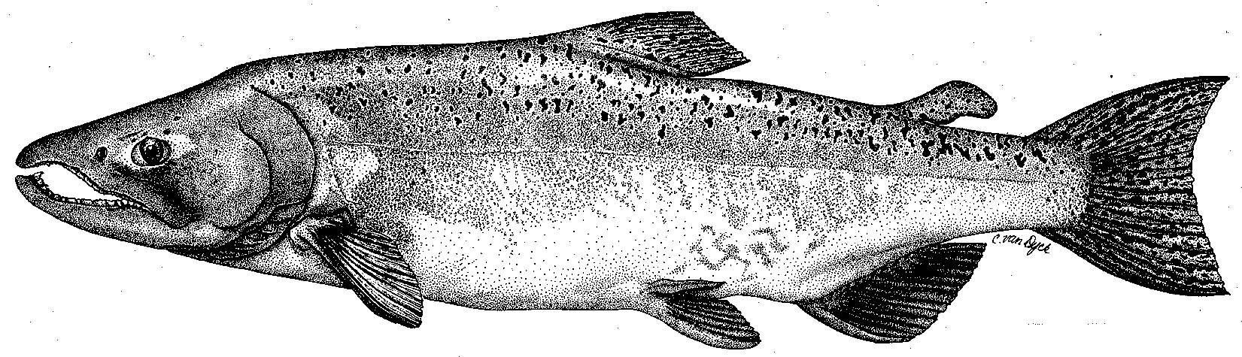

City & County of San Francisco
California Department of Fish & Game
U. S. Fish & Wildlife Service
333 East Canal Drive
Turlock, CA 95381-0949
Phone: (209) 883-8214
Fax: (209) 656-2180
Email: rmnees@tid.org

TECHNICAL ADVISORY COMMITTEE MEETING
8 March 2012 at 9:30 AM
Turlock Irrigation District, Room 152

Summary

1. Introduction and Announcements
- Participants made self introductions. See attendance below.

2. Administrative Items:

Review/Revise agenda – Change made to include minimum flow requirements for 2012 including additional handouts from Wes Monier relating to; precipitation and snow forecasts in the watershed, preliminary minimum flow schedule, and projected pulse flows. Primary considerations related to available runoff under expected dry forecasts, and high flow requirements under two of the Don Pedro Relicensing studies (tracking study for W&AR-7 Predation study; bathymetric surveys for W&AR-4 Spawning Gravel study).

Approve notes from September meeting – No changes were identified. Notes for the last meeting are posted to the TRTAC website: http://tuolumnerivertac.com/

Items since last meeting – A handout list posted at http://tuolumnerivertac.com/ was reviewed. The list included meeting summaries and notes from the December 2011 TRTAC Meeting, correspondences regarding FERC Study Plan Determinations, email communication from Tuolumne River Conservancy regarding river access, and email announcement of posting the Draft 2011 O. mykiss Population Estimate Report for comment. Documents posted included the Tuolumne River 2011 O. mykiss Summary Report, the 2011 Tuolumne River Seine Report, and the 2011 Tuolumne River Snorkel Report.

3. Monitoring/Reports: (Handouts were reviewed)
- Preliminary run estimates and fish passage on the Tuolumne and Stanislaus River counting weirs were reviewed. Andrea Fuller reported Tuolumne River weir counts were 2,851 as of March 4th. There was some discussion regarding the higher proportion of 2-year old fish in the current run which would lead to lower spawning activity than the weir counts indicate. Weir operations will continue into April 2012 unless flood control releases in excess of 1,300 cfs necessitate removal.
- Results of the 2011 O. mykiss monitoring summary report were discussed; including relatively higher numbers of juvenile and adult O. mykiss encountered following flow reductions for snorkel surveys in September 2011 on the lower Tuolumne River.
- Results of the 2011 Tuolumne River O. mykiss acoustic tracking report were discussed, but no new data. A total of six fish were tagged in the March 2010 and 14 fish in fall. Tagged O. mykiss (from October 2010) remained within the Tuolumne River during the study. Although tags implanted during March 2010 were thought to have expired, no tagged fish were detected downstream of RM 44. Generally, most tagged fish were detected within 800 meters (0.5 miles) of their release location. No additional fish were tagged in 2011 due to high flows.
- The 2012 annual FERC Report status was discussed and it was noted that CDFG Grand Tab spawner data would not be available until April 2012 at the earliest and would not included as part of the 2012 FERC Summary Report.
- Other winter and spring monitoring plans: Ongoing weir operations, seining surveys, rotary screw trap operations, and project relicensing studies were discussed for spring 2012.

4. Flow Operations:
- Indications are that 2012 will be a dry year, with a corresponding runoff of 300,000 AF, based on a 90% exceedance of DWR estimates.
- Pulse flows in May 2012 are projected to be near 2,000 cfs for five days and pulse flows in October 2012 near 625 cfs for two days, with corresponding ramping during each pulse flow period. Summer base flows are projected to be near 100 cfs during June–August 2012.

5. Agency/NGO Updates
- CDFG staffing at La Grange: It was announced that Jennifer O’Brien has left the CDFG office in La Grange and is now working for CDFG in southern California.

6. Additional items
- None

7. Next Meeting Dates – (Quarterly on 2nd Thursday at 9:30am)
- 2012 meeting dates: June 14th, September 13th, and December 13th

TRTAC Meeting Attendees

Name Organization

- Robert Nees TID
- Walter Ward MID
- Steve Boyd TID
- Andrea Fuller FISHBIO
- Noah Hume Stillwater
- Wes Monier TID

