Tuolumne River Technical Advisory Committee
Don Pedro Project - FERC License 2299

Modesto Irrigation District
Turlock Irrigation District
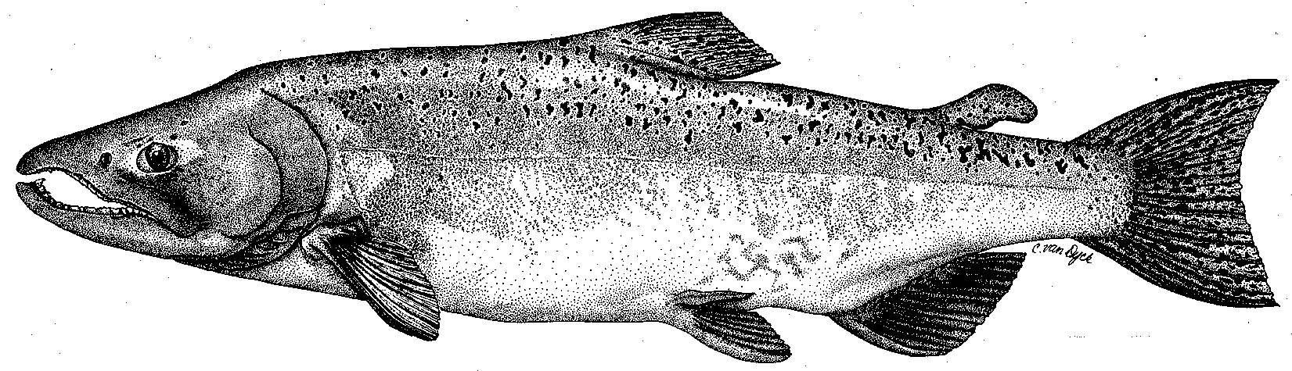

City & County of San Francisco
California Department of Fish & Game
U. S. Fish & Wildlife Service
333 East Canal Drive
Turlock, CA 95381-0949
Phone: (209) 883-8214
Fax: (209) 656-2180
Email: rmnees@tid.org

TECHNICAL ADVISORY COMMITTEE MEETING
10 March 2011 at 9:30 AM
Turlock Irrigation District, Room 152

Summary

1. Introduction and Announcements
- None

2. Administrative Items:

Review/Revise agenda – No changes

Approve notes from December 2010 meeting – No changes were identified. Notes for the last meeting are posted to the TRTAC website: http://tuolumnerivertac.com/

Items since last meeting – A handout list posted at http://tuolumnerivertac.com/ was reviewed. The list included meeting summaries, notes, and handouts from the December 2010 TRTAC Meeting, and correspondence regarding submittal of the IFIM Study Progress Report to FERC (dated December 9, 2010) and the NOI for one year VAMP extension (dated March 1, 2011). Documents posted to the website include the 2010 rotary screw trap (RST) report, the 2010 O. mykiss Acoustic Tracking Report, and the 2010 2010 O. mykiss Summary Report.

3. Monitoring/Reports: (Handouts were reviewed)
- The 2010 spawning run counts from the Tuolumne River counting weir were reviewed. Due to high flows resulting from early season runoff, spawner surveys and counting weir operations were halted the week of November 30th with a cumulative season total of 766 as of that date. Walt Ward (MID) suggested that the annual escapement graph be footnoted to indicate that the 2010 escapement estimate does not include December. He also asked if the total 2010 spawning run size could be estimated based on the fraction of run sampled (FishBIO estimates that approximately 80% of the run had passed the weir as of November 30th, which would correspond to a season total of just under 1,000 fish). Ward also asked that the graph include the DFG population estimates and weir counts for 2009 and 2010. AJ Keith (Stillwater) indicated that the footnote would be added to the report graphs and tables. Keith indicated he would consult Stillwater’s statistical analyst to determine whether a 2010 population estimate could reliably be made. Subsequently, the decision was made to continue to report only the numbers counted. CDFG spawner counts will be updated when they are reported.
- The ongoing RST and seine monitoring was discussed. It was noted that the number of captures at the Grayson RST this year are much greater than in most previous years, likely due to increased survival related to high flows. Meeting participants agreed that future graphs of RST captures and size distribution should be presented with matching scales on all graphs to facilitate easy visual comparison.
- Keith provided a summary of seine results to date, noting that so far in 2011 there have been juveniles captured in the mainstem San Joaquin River both upstream and downstream of the Tuolumne. Captures upstream of the Tuolumne have been rare in previous years.
- Results of the 2010 O. mykiss Monitoring Summary Report and Acoustic Tracking Report were discussed, including observations that all tagged fish remained in the vicinity of where they were initially captured.
- Status of the high flow and IFIM studies were discussed, noting that studies are currently on hold due to high flows.
- A draft Cover Page for the 2010 Annual FERC Report was distributed, and the status of each Technical Report was briefly reviewed. Keith indicated that the 2010 Spawning Survey Report (DFG) and the 2010 Counting Weir Report (FishBIO) were still outstanding, but that all other reports are complete or nearly complete and the Annual Report is on track to be submitted to FERC on time by April 1.
- Other winter monitoring: Winter seining surveys are in progress. Preparations are being made for 2-D site surveys, IFIM surveys, and March 2011 snorkel survey, but cannot take place until flows go down.

4. Flow Operations:
- Participants noted that the current water year is classified as above-normal. Reservoirs are currently full and high flows are likely into July.
- No information was available regarding the VAMP flows or potential spring flow schedule.

5. Agency/NGO Updates
- None

6. Additional items
- None

7. Next Meeting Dates –
- Remaining 2011 meeting dates: June 9th, September 8th, and December 8th

TRTAC Meeting Attendees

Name Organization

- Robert Nees TID
- Walter Ward MID
- Roger Masuda TID
- AJ Keith Stillwater Sciences

