Tuolumne River Technical Advisory Committee
Don Pedro Project - FERC License 2299

Modesto Irrigation District
Turlock Irrigation District
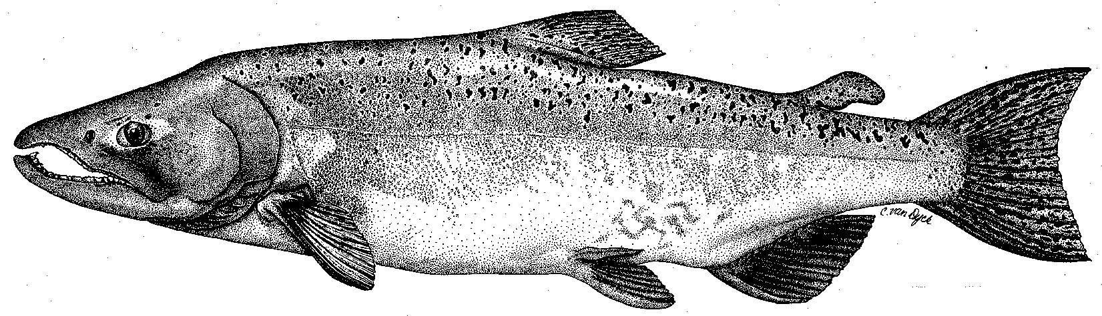

City & County of San Francisco
California Department of Fish & Game
U. S. Fish & Wildlife Service
333 East Canal Drive
Turlock, CA 95381-0949
Phone: (209) 883-8275
Fax: (209) 656-2180
Email: tjford@tid.org

TECHNICAL ADVISORY COMMITTEE MEETING
12 March 2009 at 9:30 AM
Turlock Irrigation District, Lunch Room (2nd floor)

Summary

1. Introduction and Announcements
- No fishery agencies were present.

2. Administrative Items:

Review/Revise agenda – no changes

Review notes from Dec meeting – Yoshiyama identified a couple of changes for the final summary and noted the link to the 2009 O. mykiss Study Plan led to the wrong document (has been fixed)

Items produced since last meeting – the handout listing the material posted at http://tuolumnerivertac.com/ was reviewed. It was noted that the 2008 VAMP Report did not include results of the acoustic tag study; USGS would be providing those later - there were significant problems associated with tag/equipment failure that year.

3. Monitoring/Reports:
- Salmon run data: Ford reviewed draft salmon run estimates for the Tuolumne, Merced and Stanislaus Rivers. Preliminary Petersen estimates for the Tuolumne River were 372 in 2008 vs. 211 in 2007. Stanislaus weir counts were 923 in 2008 vs. 408 in 2007, whereas Merced estimate was 464 in 2008 vs. 571 in 2007.
- Screw Trapping: Handouts on catch and size at Waterford screw trap were reviewed. Catches were low to date, with peak catch associated with recent runoff and turbidity in early March. Size of early larger salmon indicated other than fall run timing. Few salmon had been caught at Grayson.
- Turbidity data handout reviewed recurrence of excessive sediment runoff from orchard development into Peaslee Creek and the river.
- Technical Reports for 2008 FERC Report: Ford distributed a revised Table of Contents for the 2008 FERC Report and indicated a number of reports were available on the TRTAC website (http://tuolumnerivertac.com/). Still waiting on 2008 Spawning Survey Report (CDFG) and was finalizing the 2008 Snorkel Survey Report and Summary Update.
- O. mykiss Studies: Hume stated that habitat typing for the March 2009 population estimate was complete and snorkel surveys would be conducted from 16-25 March. Ford reported that work on otolith and tracking studies was not proceeding since requested 4d permits had not been issued. Sears indicated that the California Urban Water Agencies (CUWA) had switched support from valley-wide tracking studies to focusing on pelagic organism declines (POD) in the delta.
- VAMP Studies: Planned use of bubble curtain barrier at Head of Old River and 7 acoustic tagged smolt releases totaling about 1000 salmon. The 31-day flow period for Vernalis will likely run from April 20-May 20.

4. Flow Operations:
- The SJ Basin Index forecast of March 1 and resultant estimates of FERC flow volume were discussed. The 50% and 90% exceedance estimates (used due to dry year conditions) had about 149 and 113 TAF. The 50% forecast corresponded to a spring pulse flow volume of about 36 TAF and summer base flow requirement of 75 cfs. April forecasts will determine the initial volume and schedule utilized.

5. Restoration:
- No changes from Dec2008 update by Fryer.

6. Agency/NGO updates
- SFPUC
  - Sears indicated that the CCSF has allocated $16M to the SFPUC Watershed and Environmental Improvement Program (WEIP) in the 2009–2010 budget for a range of habitat programs in the upper watershed and other locations
- TRT
  - Roseman discussed funding status for the Dos Rios project due to the State Bond Fund freeze. Other sources may include Federal and State fiscal stimulus finds as well as NRCS flood easement funds. TRT has re-initiated the Tuolumne River Coalition, which held its first meeting in February and will hold another one in May. Current initiatives include the development of a map for public access to the Tuolumne River and a public awareness campaign “Paddle to the Sea” which is planned from Clavey River to SF Bay in May and June.

7. Additional items
- None.

8. Next mtg dates – Quarterly on 2nd Thursday: June 11, September 10, December 10

TRTAC Meeting Attendees

Name Organization

- Tim Ford TID/MID
- Robert Nees TID
- Roger Masuda TID
- Walter Ward MID
- Ron Yoshiyama CCSF
- Bill Sears SFPUC
- Noah Hume Stillwater Sciences
- Jesse Roseman Tuolumne River Trust

