Tuolumne River Technical Advisory Committee
Don Pedro Project - FERC License 2299

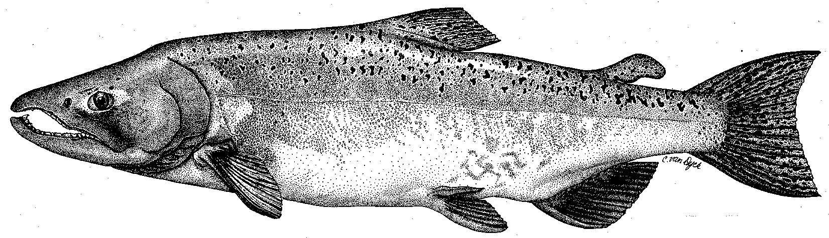

Modesto Irrigation District
Turlock Irrigation District
City & County of San Francisco
California Department of Fish & Game
U. S. Fish & Wildlife Service
333 East Canal Drive
Turlock, CA 95381-0949
Phone: (209) 883-8275
Fax: (209) 656-2180
Email: tjford@tid.org

TECHNICAL ADVISORY COMMITTEE MEETING

13 March 2008
9:30 AM
Turlock Irrigation District
Room 152 (1st floor – Civil Engineering/Water Resources)

REVISED DRAFT AGENDA

1. Introduction and Announcements

2. Comments on agenda; approve prior meeting summary (at http://tuolumnerivertac.com/); items since last meeting
3. 2007 FERC Report: contents and status, including 2007 fall run survey results
4. Monitoring: current activities: screw traps and seine; status of TRTAC grant from CALFED/DFG
5. March 1 DWR basin index forecast: potential annual fish flow volume and schedules; spring flow operations
6. VAMP: 2007 results (report at http://www.sjrg.org/); 2008 study plan and flows
7. Severe sediment runoff at River Mile 45 from Peaslee Creek watershed: monitoring and status of actions taken
8. Restoration update and status of TRTAC grants from CALFED/DFG
9. Agency/NGO updates
10. Additional items
11. Next meeting dates – Quarterly on 2nd Thursday: June 12, September 11, December 11

See also postings to TRTAC website http://tuolumnerivertac.com/

