Tuolumne River Technical Advisory Committee
Don Pedro Project - FERC License 2299

Modesto Irrigation District
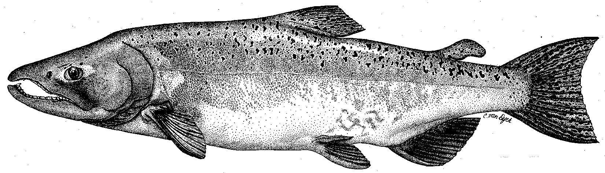

Turlock Irrigation District
City & County of San Francisco
California Department of Fish & Game
U. S. Fish & Wildlife Service
333 East Canal Drive
Turlock, CA 95381-0949
Phone: (209) 883-8275
Fax: (209) 656-2180
Email: tjford@tid.org

TECHNICAL ADVISORY COMMITTEE
MEETING MINUTES of
19 March 2003
DRAFT

1. AGENDA & PRIOR MINUTES

No Changes were made to the Agenda. Tim Ford distributed correspondence since the last meeting.

2. ACTION ITEMS:

No action items carried over from the last meeting.

- GENERAL INFORMATION:

- FSA/Order Activities: Subgroup meetings in January and February identified the remaining monitoring activities that are planned for the $164,000 left in the funds available for monitoring. These include thermographs, seining, and snorkeling by the Districts, and APR-MAY screw trap monitoring by DFG. Analysis of the 2002 smolt survival study data will be completed. Under restoration funding only $35,000 currently remains unallocated, pending the final closeout on SRP 9 and 7\11 Projects. DFG provided an update on the 2002 spawning monitoring. There will be no redd count report or Grayson rotary screw trap report for the FERC report this year.

- Agency Updates: J.D. Wikert, USFWS, indicated the Service is considering on a basin wide forum to meet quarterly (?) to review and exchange information from groups implementing restoration projects. Roger Masuda indicated that consideration needs to be given for project construction contracts to have change order language on time & material basis for implementing adaptive management practices during construction. Madelyn Martinez will try to bring language used by NOAA Fishery for such activities. The need for long-term project related monitoring was identified for potential Phase II CBDA funding requests.

Allison Boucher, FOTT, reported that beaver activity at Grayson River Ranch had become a problem and depredation permits would be sought. The City of Waterford tree planting went well with 70 volunteers participating. Development of a plan for Bobcat Flat was continuing. The FOTT is working on a tour to show how steelhead habitat could be incorporated into current riffle rehabilitation projects. The Ceres Bluff park area will have some of the riprap removed.

Patrick Koepele, TRPT, reported on the development of flyers and other public outreach materials for the Tuolumne River Coalition (TRC) activities. They are looking to adopt the Army COE hydraulic model for the Big Bend project. There were questions on how the TRC would handle contracting for use of Proposition bond funds; JPA, MOA, etc.

Tim Heyne, DFG, reported on the spawning use of the recent gravel additions in La Grange. The lowermost addition was little used, but the rest of the areas were used extensively. They paid more for the gravel than originally in the budget. The permits are not yet in place for additions in 2003.

Madelyn Martinez, NOAA Fisheries, indicated it requires 6 to 8 months to get through the review and public notice requirements for Section 10 Permits. There is increased emphasis on the monitoring associated with the permit.

Jeff McLain, USFWS, indicated that the FWS and NOAA Fisheries were continuing to work on the consultation coordination for VAMP flows now required for steelhead issues. Pat Brantley will be replacing Rhonda Reed as the DFG – AFRP coordinator with Jeff.

3C Monitoring: DFG reported the rotary screw trap will run only April through May due to funding and there could be some fish not counted. The Districts have been conducting the annual seining and will follow that up in June with snorkel surveys. There was discussion on expanding invertebrate studies and the level of assessment to be used. The use of a Rapid Bioassessment Method would allow a greater portion of the river to be covered, but at a lesser resolution. The intensive monitoring gives a better indication of population changes. Tim Heyne, DFG, questioned the need for invertebrate studies unless there is indication of nutritional problems in the fishery. The Stillwater report will be discussed at the next TRTAC meeting in June.

3D River Operations & Flow Schedules: The water conditions are very dry and with average from this point forward would only yield 130,000 AF available for the FERC flow schedule. The current recommendation would be to allocate this as 35,000 AF for the VAMP pulse flow period yielding 700-800 cfs average flows. The shape of the pulse flow curve is being developed for a mid-April start date.

3E Restoration Update: Wilton Fryer provided a handout on the funding and status of the projects currently being administered by the District. Monitoring fieldwork was completed as planned, with some habitat mapping left to be done in the fall.

4. ADDITIONAL ITEMS:

4A1 TRTAC GIS: Noah Hume, Stillwater Sciences, reported on a proposal to upgrade the format of the information in the current GIS database. There have been a few requests for the database layers. The old data is in ArcView format and McBain could update the layers in that format for $1,000. There is old pre-1997 flood data form La Grange to Empire (RM 21) and new Army COE photo negatives and ground data from the San Joaquin River to RM 31. It would take several days to put that data into the ArcView format. The issue to be considered is putting the river into a digital terrain model rather than the ArcView format. The digital information is easier to manipulate the ArcView information is more like a picture. No decision was made.

4A2. Trout Compilation: Allison Boucher, FOTT, proposed compiling all the information on Central Valley trout with FOTT as the contract agent. This would include steelhead use of the rivers. It was suggested the scope should be to look at just the San Joaquin River system with linkage to the existing NOAA Fishery Science lab data, the AFRP IFIM work for the San Joaquin Basin, and the DFG Biological Review Team project. FOTT will work with the TRTAC Subgroup to develop a scope of work and make a determination of what is currently being developed. It was suggested to focus on sufficient information to understand how to accommodate steelhead when restoration activities are implemented for salmon.

4A3. Noah Hume, Stillwater Sciences, reported on the “Flow vs Temperature” memo handout to the TRTAC. It is an expansion of earlier IFIM models for salmon applied to information on trout. There can be too much flow in the river, where the velocity over the riffles is no longer suitable for trout juvenile survival, even though adult habitat is expanded. The models suggest that the location of the 65 degree F temperature threshold is generally downstream of current gravel infusion projects near La Grange in normal runoff years (i.e. summer flows > 150 cfs). Flows above 150 cfs appear to provide greater downstream extant for adult trout habitat, but at the expense of upstream juvenile habitat due to higher water velocities.

4B. NEXT MEETING & TOPICS:

The next meeting will be at 0930 on Tuesday 24 June 2003.

FERC 2299 TAC Meeting

19 March 2003

Name Organization

Tim Ford TID/MID

Wilton Fryer TID

Roger Masuda TID

Patrick Koepele TRPT

Jeff McLain USFWS

J. D. Wikert USFWS

Allison Boucher FOTT

Ron Yoshiyama CCSF

Noah Hume Stillwater Sciences

Tim Heyne DFG

Madelyn Martinez NMFS

