Tuolumne River Technical Advisory Committee
Don Pedro Project - FERC License 2299

Modesto Irrigation District
Turlock Irrigation District
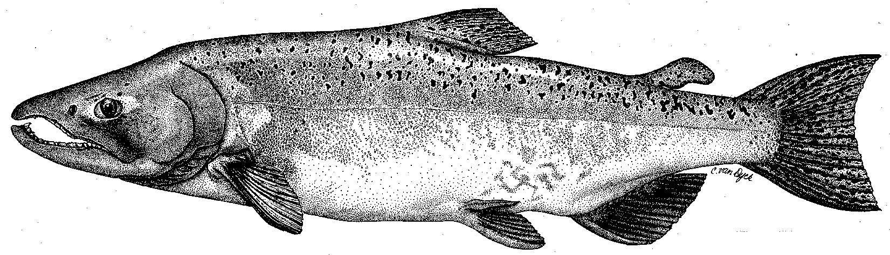

City & County of San Francisco
California Department of Fish & Game
U. S. Fish & Wildlife Service
333 East Canal Drive
Turlock, CA 95381-0949
Phone: (209) 883-8275
Fax: (209) 656-2180
Email: rmnees@TID.org

TECHNICAL ADVISORY COMMITTEE MEETING
June 14, 2012 at 9:30 AM
Turlock Irrigation District, Room 152 (1st floor)

DRAFT AGENDA

1. Introduction and Announcements

2. Administrative Items:

Review/revise agenda

Approve notes from March 2012 meeting

Items since last meeting

3. Monitoring/Reports:
- Review spring monitoring (Seine, RSTs)
- Instream Flow Studies (High Flow HSC, Draft 2012 Pulse Flow Report)
- Spring FERC Studies (spawning gravel study, predation study, scale study)
- Planned summer 2012 FERC Relicensing studies (Ops. Model/Accretion, Spawning gravels, Predation, O. mykiss/LWD, Riparian)
- Other summer 2012 Monitoring (IFIM low flow surveys, Reference count snorkeling, Water temperature)

4. Flow Operations:
- Review spring flows and forecasts.
- Summer operations

5. Agency/NGO updates

6. Additional items

7. Next meeting dates – September 13, December 13, March 14, 2013

