Tuolumne River Technical Advisory Committee
Don Pedro Project - FERC License 2299

Modesto Irrigation District
Turlock Irrigation District
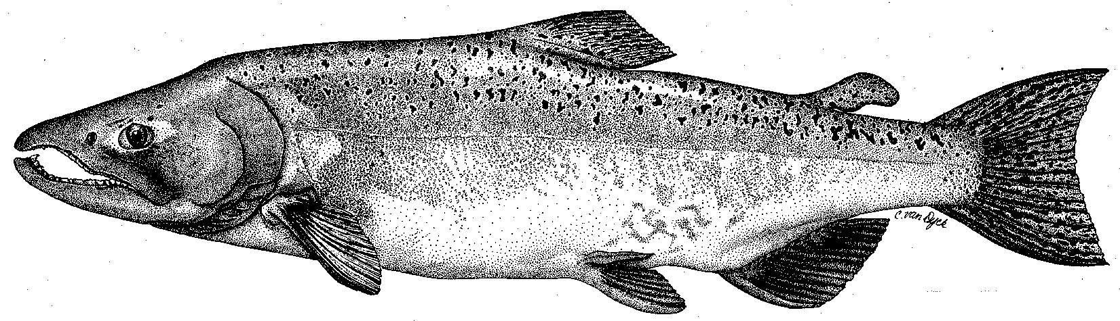

City & County of San Francisco
California Department of Fish & Game
U. S. Fish & Wildlife Service
333 East Canal Drive
Turlock, CA 95381-0949
Phone: (209) 883-8275
Fax: (209) 656-2180

TECHNICAL ADVISORY COMMITTEE MEETING
June 9, 2011 at 9:30 AM
Turlock Irrigation District, Room 152 (1st floor)

Summary

1. INTRODUCTION AND ANNOUNCEMENTS
- See attendance below

2. ADMINISTRATIVE ITEMS:
- Review/revise agenda – No changes

Approved notes from March 2011 meeting – No changes were identified. Notes for the last meeting are posted to the TRTAC website: http://tuolumnerivertac.com/
- Items since last meeting – A handout list of postings at http://tuolumnerivertac.com/ was reviewed, including:
  - meeting summaries, notes, and handouts from the March 2011 TRTAC meeting
  - correspondence regarding Don Pedro Hydroelectric Project’s Scoping Document 1 (dated April 8, 2011), Notice of Intent to file a License Application, Pre Application Document, scoping request for comments etc (Dated April 8, 2011), and the Districts letter to fishery agencies regarding the minimum flow schedule for 2010–2011 (Dated April 12, 2011)
  - documents posted to the website, including the 2010 FERC Annual Report and the Lower Tuolumne River Water Temperature Modeling Study
3. MONITORING/REPORTS:
- Reviewed the 2011 spring monitoring RST counts and seine data from the Tuolumne River. To date, 4,223 Chinook salmon have been captured at the rotary screw traps at Waterford, and 1,574 have been captured at Grayson. Debbie requested information regarding efficiency tests conducted in 2011, which will be included in the 2011 report.
- There are potentially five studies planned during 2011:
- Instream Flow overbank study – fieldwork ongoing through summer 2011
- Instream flow IFIM study – Transect placement complete; fieldwork scheduled for July–September, depending on flows
- O. Mykiss reference count survey – requires < 300 cfs, planned for September and November.
- O. Mykiss population estimate surveys – requires < 300 cfs (final year of this study), fieldwork scheduled for July–September, depending on flows.
- Instream flow IFIM study habitat suitability surveys for O. Mykiss and Chinook salmon, delayed to 2012 due to high flows.

4. FLOW OPERATIONS:
- Reviewed spring Tuolumne River flows and forecasted flows through summer
  - Flows depend on the weather, but anticipate ~ 4,600 cfs into mid July.
  - Low irrigation demand this spring due to wet weather conditions
  - Walt Ward mentioned a recent canal spill
- Reviewed spring San Joaquin River flows and delta exports
  - Basin flows and delta CVP/SWP exports graphs were reviewed. Vernalis flows during VAMP were high, but so were exports. It appears that DWR went with the 1:1 ratio for pumping, which resulted in large fish takes.

5. AGENCY/NGO UPDATES
- None

6. ADDITIONAL ITEMS
- Debbie suggested that we may want to move the September meeting to October, when more of the studies will have been completed. No decision was made.

7. NEXT MEETING DATES – SEPTEMBER 8, DECEMBER 8

TRTAC Meeting Attendees

Name Organization

- Debbie Liebersbach TID
- Walter Ward MID
- Steve Boyd TID
- Russ Liebig Stillwater Sciences
- Rodger Masuda TID

