Tuolumne River Technical Advisory Committee
Don Pedro Project - FERC License 2299

Modesto Irrigation District
Turlock Irrigation District
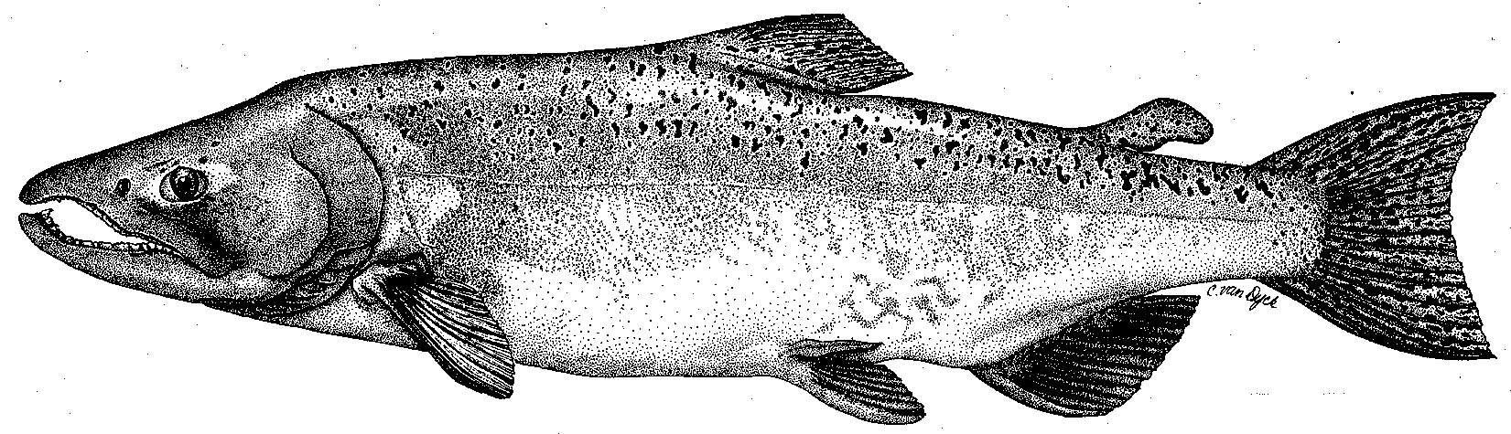

City & County of San Francisco
California Department of Fish & Game
U. S. Fish & Wildlife Service
333 East Canal Drive
Turlock, CA 95381-0949
Phone: (209) 883-8275
Fax: (209) 656-2180
Email: tjford@tid.org

TECHNICAL ADVISORY COMMITTEE MEETING
June 10, 2010 at 9:30 AM
Turlock Irrigation District, Room 152 (1st floor)

DRAFT AGENDA

1. Introduction and Announcements

2. Administrative Items:

Review/revise agenda

Approve notes from March 2010 meeting

Items since last meeting

3. Monitoring/Reports:
- May FERC Orders on studies
- Review spring monitoring
- Planned studies for rest of 2010

4. Flow Operations:
- Review spring Tuolumne River flows and forecasted flows
- Review spring San Joaquin River flows and delta exports

6. Agency/NGO updates

7. Additional items

8. Next meeting dates – September 9, December 9

