Tuolumne River Technical Advisory Committee
Don Pedro Project - FERC License 2299

Modesto Irrigation District
Turlock Irrigation District
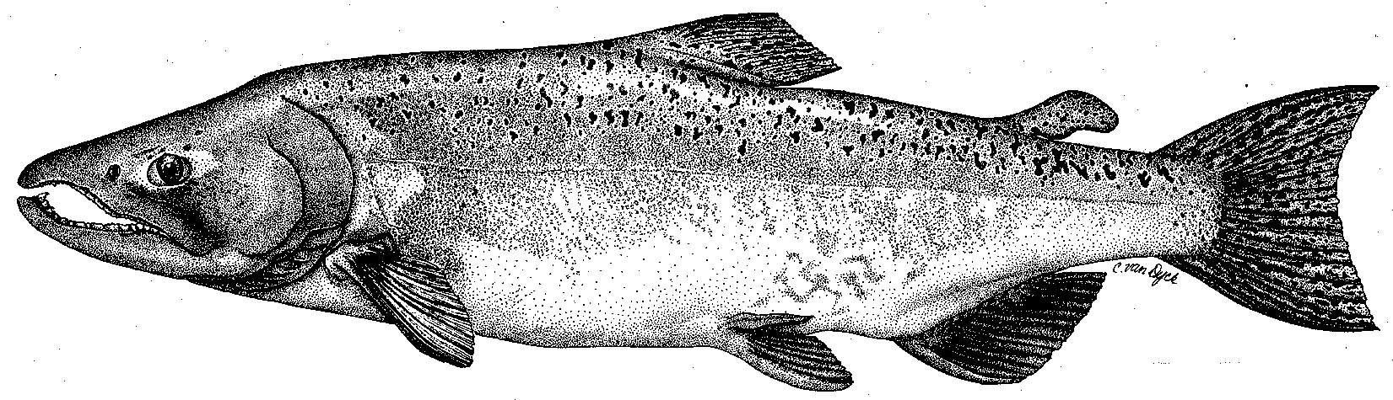

City & County of San Francisco
California Department of Fish & Game
U. S. Fish & Wildlife Service
333 East Canal Drive
Turlock, CA 95381-0949
Phone: (209) 883-8275
Fax: (209) 656-2180
Email: tjford@tid.org

TECHNICAL ADVISORY COMMITTEE MEETING
11 June 2009 at 9:30 AM
Turlock Irrigation District, Lunch Room (2nd floor)

Summary

1. Introduction and Announcements
- No fishery agencies were present.

2. Administrative Items:

Review/Revise agenda – no changes

Review notes from March meeting – no changes were identified

Items since last meeting – the handout listing the material posted at http://tuolumnerivertac.com/ was reviewed. Those included the annual report to FERC, two flow schedule letters, and a letter to FERC notifying that two of the steelhead studies would not be done due to lack of agency permits. The RM 30-40 mapping was an extension of the habitat typing done in 2008 from RM 40-52.

3. Monitoring/Reports: Handouts were reviewed
- Screw Trapping: Handouts on catch and size at Waterford and Grayson screw trap sites were reviewed. Catches were low at Grayson (153) relative to Waterford (3,680) and mainly only smolts; peak catches were associated with turbid conditions in March and May at Waterford and in May at Grayson. Fry were also caught at Waterford in Apr-May and some salmon from 70-130 mm were caught in Jan-Feb.
- Turbidity data was reviewed showing recurrent excessive sediment conditions in the river in 2008-2009. The early May 2009 event occurred during pulse flows and (1) was the highest of the season at Waterford and (2) resulted in the Tuolumne River increasing the turbidity of the San Joaquin River as the Peaslee Creek sediment plume was conveyed far downstream.
- Seining size and catch data was reviewed. An unusually large number of salmon were captured in early June.
- O. mykiss pop. estimate: Stillwater observed only 13 trout in their March survey, with a preliminary expansion to about 100-200 fish. Effort was spread over the longer RM 30-52 reach. About 5,000 juvenile salmon were seen, which may have complicated ID of trout, with an expanded estimate of about 25,000. A report including both the March and July surveys will be done later this year.

4. Flow Operations:
- The SJ Basin Index forecast range had narrowed to about 2.5-2.8 MAF with corresponding FERC flow volume ranging from 149,206-197,392 AF.
- Pulse flows had met or exceeded scheduled amounts in the period starting April 16; summer requirement starting June 16 would be 75 cfs.
- Reservoir storage status from CDEC was in the handouts and was much improved over prior year.
- Basin flows and delta CVP/SWP exports graphs were reviewed. Vernalis flows during VAMP varied, in part due to Merced flow changes; delta export was higher than usual during VAMP at those flow conditions.

5. Agency/NGO updates
- SFPUC
  - Sears reported on a 5-year time extension agreement with the East Stanislaus RCD for remaining expenses of Article 19 funds. There will be $2M from the SFPUC Watershed and Environmental Improvement Program (WEIP) for Lower Tuolumne projects yet to be selected.
- TRT
  - Roseman reported on their Green on the Stream event with over 500 attendees and their Paddle to the Sea event that had over 200 participants. Some problems were encountered in the power boating down the San Joaquin River due to shallow water.

6. Additional items
- None.

7. Next mtg dates – Quarterly on 2nd Thursday: September 10, December 10

TRTAC Meeting Attendees

Name Organization

- Tim Ford TID/MID
- Robert Nees TID
- Roger Masuda TID
- Walter Ward MID
- Bill Sears SFPUC
- Andie Irons SFPUC
- Jesse Roseman Tuolumne River Trust

