Tuolumne River Technical Advisory Committee
Don Pedro Project - FERC License 2299

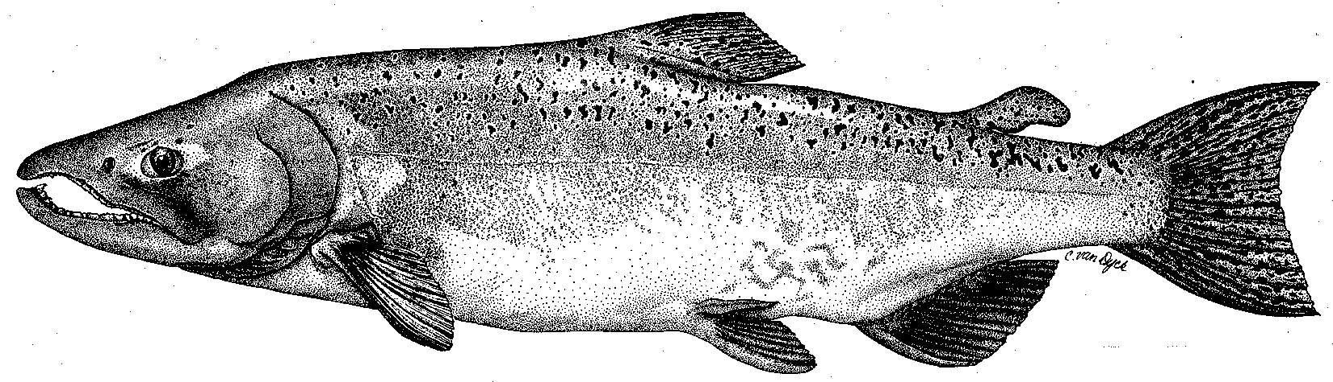

Modesto Irrigation District
Turlock Irrigation District
City & County of San Francisco
California Department of Fish & Game
U. S. Fish & Wildlife Service
333 East Canal Drive
Turlock, CA 95381-0949
Phone: (209) 883-8275
Fax: (209) 656-2180
Email: tjford@tid.org

TECHNICAL ADVISORY COMMITTEE MEETING
11 June 2009 at 9:30 AM
Turlock Irrigation District, Lunch Room (2nd floor)

DRAFT AGENDA

1. Introduction and Announcements

2. Administrative Items:

Review/revise agenda

Approve notes from March 2009 meeting

Items since last meeting

3. Monitoring/Reports:
- Review winter/spring monitoring
- Planned summer studies
- 2008 FERC Report distribution

4. Flow Operations:
- Review spring flows and current schedule/operations
- Latest forecast of basin index and annual fish flow volume

6. Agency/NGO updates

7. Additional items

8. Next meeting dates – September 10, December 10

