Tuolumne River Technical Advisory Committee
Don Pedro Project - FERC License 2299

Modesto Irrigation District
Turlock Irrigation District
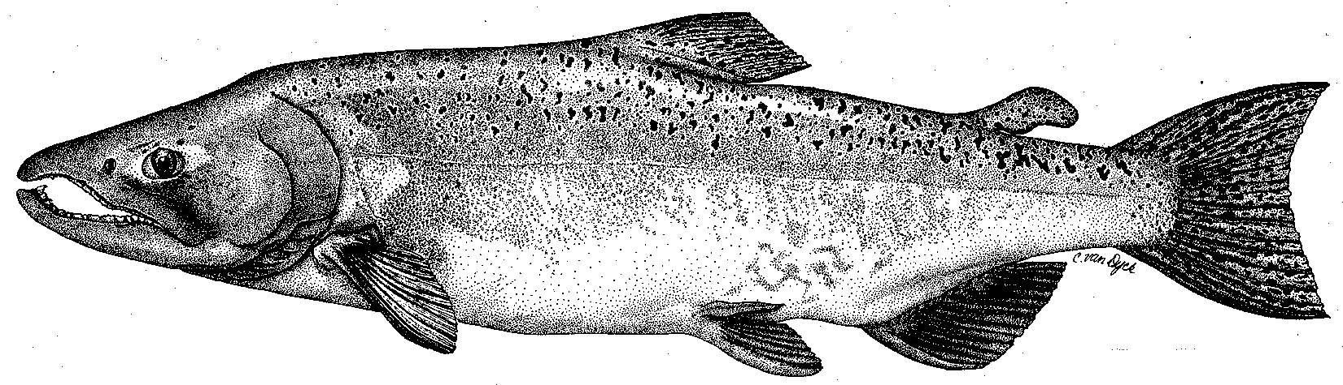

City & County of San Francisco
California Department of Fish & Game
U. S. Fish & Wildlife Service
333 East Canal Drive
Turlock, CA 95381-0949
Phone: (209) 883-8275
Fax: (209) 656-2180
Email: tjford@tid.org

TECHNICAL ADVISORY COMMITTEE MEETING
12 June 2008 at 9:30 AM
Turlock Irrigation District, Lunch Room (2nd floor)

Summary

1. Introduction and Announcements
No fishery agencies were present

2. Administrative Items:

Review/Revise agenda – no changes

Approve notes from March 13, 2008 meeting – no changes

Items produced since last meeting – reviewed the handout listing material posted at http://tuolumnerivertac.com/

3. 2007 Report to FERC
Copy was provided to those that did not already have one

4. Monitoring:
- Review screw trap and seine results – several handouts were reviewed
  - Screw trap catches at both sites had fry pulses timed with winter runoff events; both sites had some larger-sized winter outmigrants (non-fall run?); catch at Waterford was higher and more consistent relative to Grayson, but sizes were comparable; DFG provided some efficiency test fish only for Grayson; Waterford catch was used for limited efficiency tests there
  - Seine catch density was very low and size range during season was typical
  - Discuss summer work, incl. trout studies – trout data summary is in FERC Report; Hume stated some preliminary FERC trout study details, which are still being developed; permit aspects were mentioned as a potential limiting issue for implementation
- Discuss status of TRTAC monitoring grant – DFG has not provided any of the $1.26 million in approved CALFED funds; Districts have continued to conduct some monitoring that would be funded from that TRTAC grant submittal

5. Flow Requirements:
- Review of spring flow operations – graph of pulse flow was reviewed; two peaks at about 1300 cfs were provided with 800 cfs following; includ VAMP supplemental flow
- Discuss status of DWR basin index forecast, the annual fish flow volume, and current flow schedule
  - 2008 volumes based on 50% and 90% index forecasts were compared with 2004 and 2007 (other dry years with dry spring periods) – 2008 appears to be between those two years
  - Summer minimum requirement is 50 cfs with no fall pulse required in each case
  - 90% result would mean reduction in fall/winter base flow requirement of 11 cfs (down to 139 cfs from 150 cfs) due to higher volume chosen by agencies for spring pulse release

6. VAMP:
- Discuss 2008 study and flows
  - Using higher Tuolumne pulse partly enabled a Vernalis flow target of 3200 cfs instead of 2000 cfs – result was supplemental flows for higher VAMP target
  - Exports were about 1500 cfs during VAMP and were lower overall this year due to delta smelt requirements
  - Acoustic tag study results not available yet, but some problems were initially reported for tags and receivers
- Review preliminary Mossdale trawl data
  - Handout of Apr-May average salmon catch/tow was reviewed (no size data yet)
  - Peak catch rate was in mid-May, but two days were not sampled within the peak period

7. Peaslee Creek Watershed Sediment Issues:
- Discuss winter sediment runoff from Peaslee Creek watershed, monitoring being conducted to evaluate impacts, and status of actions taken
  - Districts are having assessment done by McBain and Trush (sediment and invertebrates sampled in late May)
  - Primary regulatory action to date is Regional Board’s Cleanup and Abatement Order, but that does not deal with river impacts; status of any fishery agency action is unknown
  - FOT wants to pursue better enforcement and is concerned about impacts on trout spawning; also concerned about floodplain encroachment of nursery near Waterford
  - A recommendation was made to document various impacts along entire river

8. Restoration :
- Review update of projects (see handout from Fryer for details)
  - DFG is withholding $469,836 in reimbursement on the Gasburg Creek Project
- Discuss status of TRTAC grants for gravel additions and mining reach restoration
  - DFG has not provided CALFED funds for TRTAC projects: Gravel Addition Project (about $3.98 million) and Mining Reach Project (about $10.8 million)

9. Agency/NGO updates
- FOT
  - Lot line adjustment enabling 34-acre land purchase in Bobcat Flat area using funds through ESRCD
  - Grayson tour on Monday morning
  - AFRP grant application for $200K for more gravel additions at lower Bobcat Flat; would use about $175 of onsite sorted gravel as their contribution; using McBain and Trush for design; will seek more funds if grant is approved
- River Partners
  - Restoring area near Caswell State Park; they are already restoring a large area on another part of the SJR refuge project on the west side

10. Additional items

11. Next meeting dates – Quarterly on 2nd Thursday: September 11, December 11

