Tuolumne River Technical Advisory Committee
Don Pedro Project - FERC License 2299

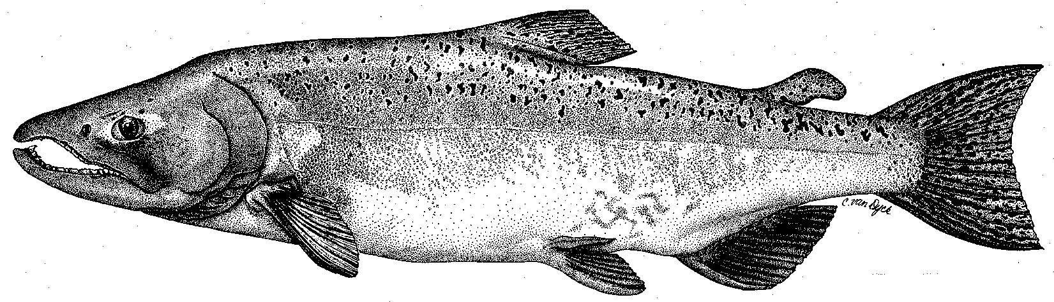

Modesto Irrigation District
Turlock Irrigation District
City & County of San Francisco
California Department of Fish & Game
U. S. Fish & Wildlife Service
333 East Canal Drive
Turlock, CA 95381-0949
Phone: (209) 883-8275
Fax: (209) 656-2180
Email: tjford@tid.org

TECHNICAL ADVISORY COMMITTEE MEETING
12 June 2008 at 9:30 AM
Turlock Irrigation District, Lunch Room (2nd floor)

DRAFT AGENDA

1. Introduction and Announcements

2. Administrative Items:

Review/Revise agenda

Approve notes from March 13, 2008 meeting

Items produced since last meeting

3. 2007 Report to FERC: Discuss submittal to FERC and provide hardcopies

4. Monitoring:
- Review screw trap and seine results
- Discuss summer work, incl. trout studies
- Discuss status of TRTAC monitoring grant

5. Flow Requirements:
- Review of spring flow operations
- Discuss status of DWR basin index forecast, the annual fish flow volume, and current flow schedule

6. VAMP:
- Discuss 2008 study and flows
- Review preliminary Mossdale trawl data

7. Peaslee Creek Watershed Sediment Issues:
- Discuss winter sediment runoff from Peaslee Creek watershed, monitoring being conducted to evaluate impacts, and status of actions taken

8. Restoration :
- Review update of projects
- Discuss status of TRTAC grants for gravel additions and mining reach restoration

9. Agency/NGO updates

10. Additional items

11. Next meeting dates – Quarterly on 2nd Thursday: September 11, December 11

