Tuolumne River Technical Advisory Committee
Don Pedro Project - FERC License 2299

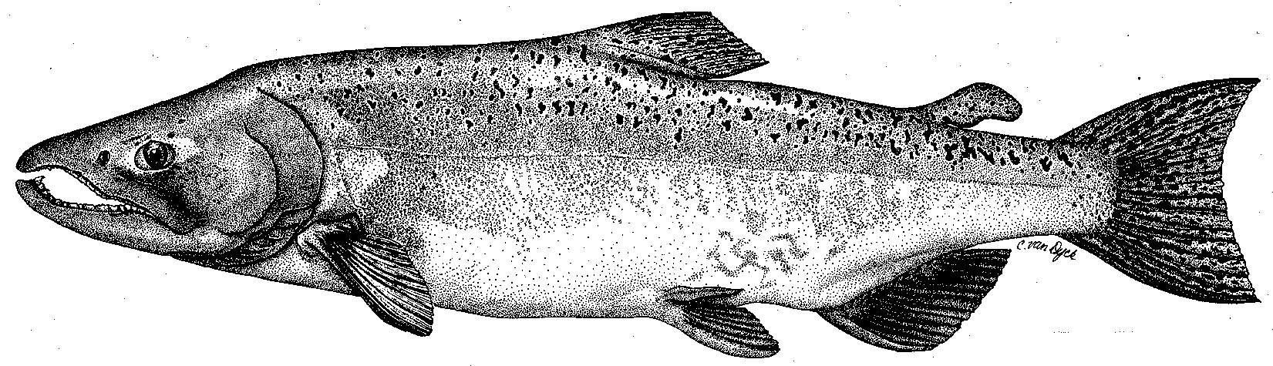

Modesto Irrigation District
Turlock Irrigation District
City & County of San Francisco
California Department of Fish & Game
U. S. Fish & Wildlife Service
333 East Canal Drive
Turlock, CA 95381-0949
Phone: (209) 883-8275
Fax: (209) 656-2180
Email: tjford@tid.org

TECHNICAL ADVISORY COMMITTEE MEETING

14 June 2007
9:30 AM
Turlock Irrigation District, Lunch Room (2nd floor)

Draft Summary

1. Introduction
- Comments on draft agenda – none

2. Items since Mar2007 meeting

Comments on material list – the listed items were reviewed; send comments on Mar meeting notes

3. General Updates

Data and report status; distribution of annual report

Ford provided 2006 annual report to several attendees

Hume reported invertebrate report work was presently on hold

Li requested copy of seine data sheets already being provided to CDFG and FWS by Districts

- Agency and NGO updates
  - FOT – the Bouchers are relocating to Oregon for several years but will still be involved with FOT and TRTAC
  - TRT - Koepele stated Meg Gonzalez is new staff person in Modesto; she had developed 4th grade Trekking the Tuolumne curriculum for the Great Valley Museum

- Monitoring update
- Hume reported a NMFS Section 10 permit for trout monitoring had been obtained
- TRTAC monitoring grant funding administered by CDFG has still not been released to TID
- Ford provided handout on salmon catch from the Waterford and Grayson screw traps for the season and noted that only about 30 salmon (all in April) were caught at Grayson; another handout showed the size of salmon caught at Waterford

- Restoration update
  - Handout of updated TRTAC project status from Fryer (TID) was briefly reviewed:
    - Gasburg Project will start in about a week
    - CDFG delayed approval of amendment to TRTAC gravel addition project in May so no gravel will be added this year
    - CDFG requested delay of $10.8 million contract award in 2006 for TRTAC Warner-Deardorff channel restoration project and that funding is still not awarded – a redesign has been submitted to combine with the adjacent TRTAC Ruddy reach project which had already lost funding for construction
  - Boucher reported:
    - A proposed 32 acre parcel split variance would result in a 29 acre addition to their Bobcat Flat property
    - 22Jun tours will be held at Bobcat Flat and Grayson River Ranch
    - Ceres has tour of new river park off Hatch Road at 2 pm on 13Jun (day of meeting)
  - Koepele reported:
    - Big Bend tree planting was completed and smaller vegetation will be added in next two years
    - Monitoring report may be available by end of year
    - Stillwater Sciences poster of monitoring for CALFED meeting is available online (check with Hume)
  - Discussion of stalled restoration grant for TRTAC gravel addition project being administered by CDFG and measures Districts have employed to attempt to move process forward; Boucher indicated a letter urging CDFG to provide funds may be sent; Koepele suggested TRTAC project selection be reviewed again

4. River operations and forecasts – Flow schedule

Ford provided handout of current flow schedule – summer schedule presently at 95 cfs and subject to change; estimated annual volume used was 117,335 AF with final volume not known until August

5. Additional items
- Li stated he completed a draft of a NMFS Tech. Advisory Bulletin on the Delta that could be out in July

6. Next meetings and topics:
- 13 September and 13 December, starting at 9:30 AM at TID

FERC 2299 TRTAC Meeting

14 June 2007

Name Organization

Tim Ford TID/MID
Robert Nees TID
Roger Masuda TID
Bill Johnston MID
Ron Yoshiyama CCSF
Rick Burmester USFWS
Noah Hume Stillwater Sciences
Allison Boucher FOT
Stacy Li NMFS (phone)
Patrick Koepele TRT (phone)

