Tuolumne River Technical Advisory Committee
Don Pedro Project - FERC License 2299

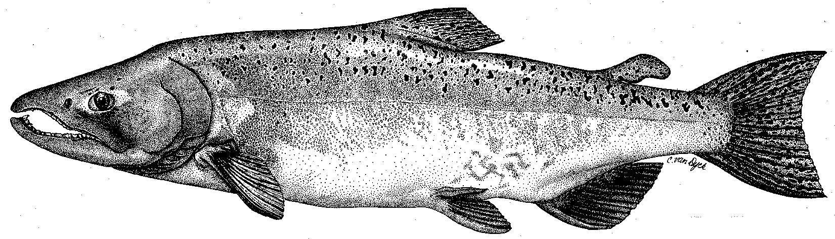

Modesto Irrigation District
Turlock Irrigation District
City & County of San Francisco
California Department of Fish & Game
U. S. Fish & Wildlife Service
333 East Canal Drive
Turlock, CA 95381-0949
Phone: (209) 883-8275
Fax: (209) 656-2180
Email: tjford@tid.org

TECHNICAL ADVISORY COMMITTEE MEETING

14 June 2007
9:30 AM
Turlock Irrigation District, Lunch Room (2nd floor)

DRAFT AGENDA

1. Introduction - Comments on draft agenda

2. Items since Mar2007 meeting

Review material list
3. General Update

Data and report status; distribution of Annual Report
- Agency and NGO updates
- Monitoring update – completed and planned activities

Restoration status
4. River operations and forecasts – Flow schedule
5. Additional items
6. Next meetings and topics:
- 13 September and 13 December at TID

(see also information at TRTAC website: http://tuolumnerivertac.com/ )

