Tuolumne River Technical Advisory Committee
Don Pedro Project - FERC License 2299

Modesto Irrigation District
Turlock Irrigation District
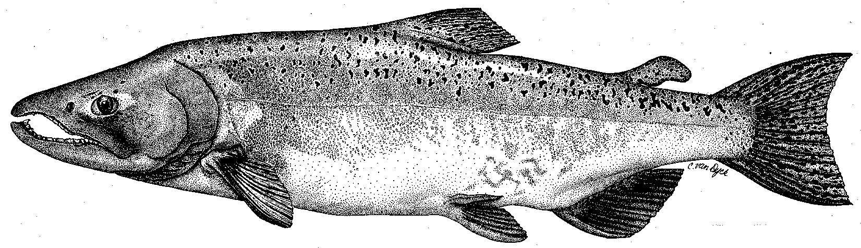

City & County of San Francisco
California Department of Fish & Game
U. S. Fish & Wildlife Service
333 East Canal Drive
Turlock, CA 95381-0949
Phone: (209) 883-8364
Fax: (209) 605-3036
Email: seboyd@tid.org@tid.org

TECHNICAL ADVISORY COMMITTEE MEETING
13 December 2012 at 9:30 AM
Turlock Irrigation District, Room 152

Summary

1. Introduction and Announcements
- Participants made self introductions.
- There was a brief discussion regarding the Revised Study Plan filed with FERC for the ongoing relicensing for the Don Pedro Project. For further updates on the relicensing process, please visit: http://www.donpedro-relicensing.com/default.htm.

2. Administrative Items:

Review/Revise agenda – No changes

Approve notes from September meeting – No changes were identified. Notes for the last meeting are posted to the TRTAC website: http://tuolumnerivertac.com/

Items since last meeting – A handout list posted at http://tuolumnerivertac.com/ was reviewed. The list included meeting summaries and notes from the September TRTAC Meeting and relicensing participant meeting summaries (W&AR-2 Hydrology, W&AR-3, 16 Water Temperature Models, W&AR-6 and 10 salmonid population models, W&AR-4 Temperature Criteria, and W&AR-15 Socioeconomics). Other correspondence included Water Year classification and Fall Pulse Flow schedules, requests for extension of the Initial Study Report of the Don Pedro Relicensing, correspondences regarding exceedances of temperature criteria, and filing of workshop notes on the Salmonid Information Synthesis Study as part of the ongoing Don Pedro Project Relicensing with FERC. Updated data records posted included the San Joaquin Basin Newsletter Archives, Seine and Weir data for 2011, and snorkel data for 2010-2012. No new documents were posted since the September 2012 TRTAC meeting.

3. Monitoring/Reports: (Handouts were reviewed)
- Preliminary run estimates and fish passage on the Tuolumne and Stanislaus River counting weirs were reviewed. Tuolumne River weir counts were 2,069 as of December 10th. There was a lower proportion of hatchery fin-clipped fish, as well as a lower proportion of 2-year old fish in the current run which would suggest higher juvenile production may result from winter 2012-2013 spawning activity. Weir operations will continue into April 2012 unless flood control releases in excess of 1,300 cfs necessitate removal.
- Final 2012 thermograph download was completed the week of December 3/2012 with data transferred to HDR and FIHSBIO for use in various technical reports. Thermograph previously located at Bobcat Flat (RM 43) was relocated closer to TLSRA (RM 42). A decision was reached at the meeting to re-establish the RM 43 site to develop a statistical record of corresponding temperatures between the two sites.
- Weekly redd counts for Chinook salmon spawning will continue through December, shifting to biweekly from January through April to document any potential O. mykiss spawning activity in spring 2013.
- Technical Reports to be included in the 2012 FERC Report were distributed as a draft Table of Contents, with a number of reports available on the TRTAC website (snorkel only). Seine and RST report Drafts have been completed and are in review.
- Other winter monitoring plans: Ongoing weir operations, redd-mapping, seining surveys, rotary screw trap operations, and project relicensing studies are planned for winter and spring 2013 such as low flow accretion measurements included as part of Study W&AR-2.

4. Flow Operations:
- Current Tuolumne River flows are approximately 175 cfs to the lower river. The MID canal is currently out of service for winter maintenance.

5. Agency/NGO Updates
- None

6. Additional items
- None

7. Next Meeting Dates – (Quarterly on 2nd Thursday at 9:30am)
- 2012 meeting dates: March 14th, June 13th, September 12th, and December 12th

TRTAC Meeting Attendees

Name Organization

- Steve Boyd TID
- Walter Ward MID
- Patrick Maloney TID
- Andrea Fuller FISHBIO
- Noah Hume Stillwater

