Tuolumne River Technical Advisory Committee
Don Pedro Project - FERC License 2299

Modesto Irrigation District
Turlock Irrigation District
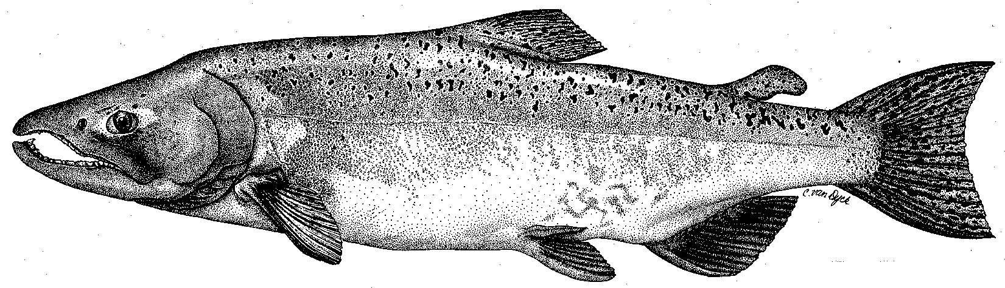

City & County of San Francisco
California Department of Fish & Game
U. S. Fish & Wildlife Service
333 East Canal Drive
Turlock, CA 95381-0949
Phone: (209) 883-8214
Fax: (209) 656-2180
Email: rmnees@tid.org

TECHNICAL ADVISORY COMMITTEE MEETING
8 December 2011 at 9:30 AM
Turlock Irrigation District, Room 152

Summary

1. Introduction and Announcements
- Participants made self introductions.
- There was a brief discussion regarding the Revised Study Plan filed with FERC for the ongoing relicensing for the Don Pedro Project. For further updates on the relicensing process, please visit: http://www.donpedro-relicensing.com/default.htm.

2. Administrative Items:

Review/Revise agenda – No changes

Approve notes from September meeting – No changes were identified. Notes for the last meeting are posted to the TRTAC website: http://tuolumnerivertac.com/

Items since last meeting – A handout list posted at http://tuolumnerivertac.com/ was reviewed. The list included meeting summaries and notes from the September TRTAC Meeting, correspondences regarding schedule extension of the ongoing FERC IFIM study, submittal of the Districts ILP Study Plan, NMFS submission of supplemental information to FERC, and updates to the 2011 Flow Schedule. Documents include the Draft 2011 O. mykiss monitoring report, the ILP Revised and Updated Study Plans for the Don Pedro Project Relicensing.

3. Monitoring/Reports: (Handouts were reviewed)
- Preliminary run estimates and fish passage on the Tuolumne and Stanislaus River counting weirs were reviewed. Tuolumne River weir counts were 2,673 as of December 4th. There was some discussion regarding hatchery releases and the higher proportion of hatchery fin-clipped fish, as well as a higher proportion of 2-year old fish in the current run which would lead to lower spawning activity than the weir counts indicate. Weir operations will continue into April 2012 unless flood control releases in excess of 1,300 cfs necessitate removal.
- Results of the 2011 O. mykiss population estimate and monitoring summary reports were discussed, including observations of larger numbers of fish during the late September snorkel surveys.
- Technical Reports for 2011 FERC Report were distributed as a draft Table of Contents, with a number of reports available on the TRTAC website (seine, snorkel, RST, September 2010 Population estimate, and Tracking Study Yr 2 report).
- Other winter monitoring plans: Ongoing weir operations, redd-mapping, seining surveys, rotary screw trap operations, and project relicensing studies are planned fror winter and spring 2012.

4. Flow Operations:
- High flows in the Tuolumne River during winter through summer 2011 were discussed. Current Tuolumne River flows are approximately 300 cfs to the lower river. The MID canal is currently out of service for winter maintenance.

5. Agency/NGO Updates
- Tuolumne River Coalition: Dave Boucher provided a written summary of site construction at Bobcat Flat (RM 43) during summer 2011. In addition to floodplain lowering, appproximately 19,000 cubic yards of coarse sediment was placed in the channel, including replenishment of one existing riffle, creation of three additional riffles as well as the placement of four new alternating point bars to serve as sediment recruitment sources as well as high velocity refuge for rearing salmonids. Although high flows limited access to the channel, construction was completed as planned.

6. Additional items
- None

7. Next Meeting Dates – (Quarterly on 2nd Thursday at 9:30am)
- 2012 meeting dates: March 8th, June 14th, September 13th, and December 13th

TRTAC Meeting Attendees

Name Organization

- Robert Nees TID
- Walter Ward (phone) MID
- Steve Boyd TID
- Andrea Fuller FISHBIO
- Noah Hume Stillwater
- Roger Masuda (phone) TID

