Tuolumne River Technical Advisory Committee
Don Pedro Project - FERC License 2299

Modesto Irrigation District
Turlock Irrigation District
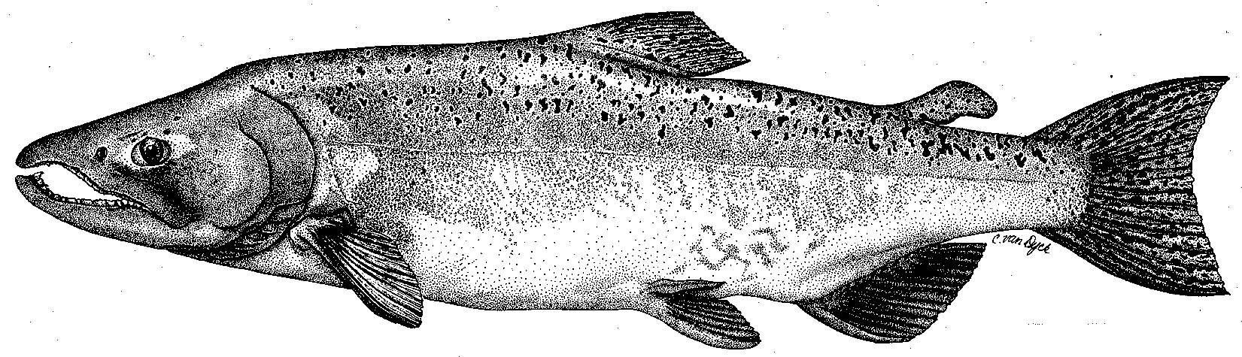

City & County of San Francisco
California Department of Fish & Game
U. S. Fish & Wildlife Service
333 East Canal Drive
Turlock, CA 95381-0949
Phone: (209) 883-8214
Fax: (209) 656-2180
Email: rmnees@tid.org

TECHNICAL ADVISORY COMMITTEE MEETING
9 December 2010 at 9:30 AM
Turlock Irrigation District, Room 152

Summary

1. Introduction and Announcements
- Participants made self introductions.
- There was a brief discussion regarding the upcoming relicensing for the Don Pedro Project. Relicensing will follow the integrated relicensing process (ILP) with the notice of intent (NOI) and preliminary application document (PAD) expected to be filed with FERC in February 2011. A webpage has been established to help interested parties keep abreast of relicensing activities and information. The webpage is at: http://www.donpedro-relicensing.com/default.htm. It can also be found by searching for “Don Pedro Relicensing” on the internet.

2. Administrative Items:

Review/Revise agenda – No changes

Approve notes from September meeting – No changes were identified. Notes for the last meeting are posted to the TRTAC website: http://tuolumnerivertac.com/

Items since last meeting – A handout list posted at http://tuolumnerivertac.com/ was reviewed. The list included meeting summaries and notes from the September TRTAC Meeting and IFIM workgroup, correspondences regarding Agency review of the 2010 O. mykiss monitoring and water temperature modeling reports, and 2-D site-selection rationale memorandum. In addition, FERC Progress Reports on the Water Temperature Modeling Study and IFIM studies were posted at the FERC e-Library. Documents include the 2010 O. mykiss monitoring report, the 2010 snorkel survey report, report on the March and August 2010 O. mykiss population size estimates in the lower Tuolumne River, Draft water temperature modeling study report, and IFIM study meso-habitat maps.

3. Monitoring/Reports: (Handouts were reviewed)
- Data posted on the TAC website included updated 2010 thermograph data through September 27, 2010 as well as fall 2010 counting weir data.
- Preliminary run estimates and fish passage on the Tuolumne and Stanislaus River counting weirs were reviewed. Due to high flows resulting from early season runoff, spawner surveys and counting weir operations were halted the week November 30th with a cumulative season total of 766 as of that date. Flows at Modesto were on the order of 3,000 cfs as of December 9th and since flows <500 cfs are needed for re-installation of the weir an unknown number of additional fish may move upstream without detection. FishBIO estimates that approximately 80% of the run had passed the weir as of November 30th, which would correspond to a season total of just under 1,000 fish.
- Alison and Dave Boucher (TRC) requested continuation of counting operations during spring pulse flows to detect upstream passage of any steelhead arriving in the lower river, subject to the flow limitations of the weir (~1,300 cfs).
- Results of the 2010 O. mykiss population estimate and monitoring summary reports were discussed, including observations of larger fish that may have arrived from upstream. Clarification of flow pathways and durations of bypassed flows will be included in the Final versions of both reports.
- Technical Reports for 2009 FERC Report were distributed as a draft Table of Contents, with a number of reports available on the TRTAC website (seine, snorkel, RST, March/July 2010 Population estimate, and Tracking Study Yr 1 report). Dave Boucher suggested that tracking between June and August would likely represent only resident fish and that location of spawning redds would be extraordinarily difficult as part of this study.
- Alison Boucher and Jesse Roseman (TRT) asked for details regarding the site selection of the 2-D high flow study. Noah Hume (Stillwater) described the site review process and that the Bobcat Flat (RM 43) site was removed from consideration due to planned construction changes in the site topography in 2011. In addition Big Bend (RM 6) and Grayson River Ranch sites (RM 5.5) were removed due to inability to ensure sufficient San Joaquin River flows during Tuolumne River high flow events to provide a hydraulic control and floodplain inundation (backwater effect). Jesse asked questions regarding Tuolumne Flow limitations during flood control releases. Noah will provide Jesse San Joaquin River flow estimates for dates that Big Bend site was found to flood during 2005–2006 monitoring period. Dave described the genesis of the site drainage channels at Grayson and agreed to provide location of portions of the site that may flood at 3,000 cfs.
- Other winter monitoring plans: Winter seining surveys, 2-D site surveys, IFIM surveys, and March 2011 snorkel surveys are in preparation.

4. Flow Operations:
- Recent flow operations required to maintain flood control storage in Don Pedro Reservoir were discussed. The operational goals during the December/January egg incubation period are to minimize redd scour and rapid dewatering of any redds established during high flows. Current Tuolumne River flows are approximately 3,000 cfs to the lower river, with additional flows of approximately 800 cfs being diverted through the TID canal system and released at the Hickman and Faith Home spills. The MID canal is currently out of service for winter maintenance.

5. Agency/NGO Updates
- Tuolumne River Trust: Jesse Roseman summarized TRT activities, including the 2010 Paddle to the Sea fund-raising event, Dos Rios land acquisition, and Dennett Dam draft removal report preparation progress.
- Tuolumne River Coalition: Dave Boucher summarized TRC activities including the site construction plans scheduled at Bobcat Flat (RM 43) during summer 2011. Plans include floodplain lowering to provide inundation at 3,000 cfs, repair/removal of side channels, construction of point bar complexes, and gravel augmentation. Dave requested that if either IFIM transect surveys or habitat suitability surveys were to result in flows near 100 cfs, the TRC would like to have advance notice to allow coordination of in-channel work activities at Bobcat Flat.

6. Additional items
- None

7. Next Meeting Dates – (Quarterly on 2nd Thursday at 9:30am)
- 2011 meeting dates: March 10th, June 9th, September 8th, and December 8th

TRTAC Meeting Attendees

Name Organization

- Walter Ward MID
- Debbie Liebersbach TID
- Dave Boucher Tuolumne River Coalition (TRC)
- Alison Boucher TRC
- Jesse Roseman Tuolumne River Trust (TRT)
- Noah Hume Stillwater
- Roger Masuda TID

