Tuolumne River Technical Advisory Committee
Don Pedro Project - FERC License 2299

Modesto Irrigation District
Turlock Irrigation District
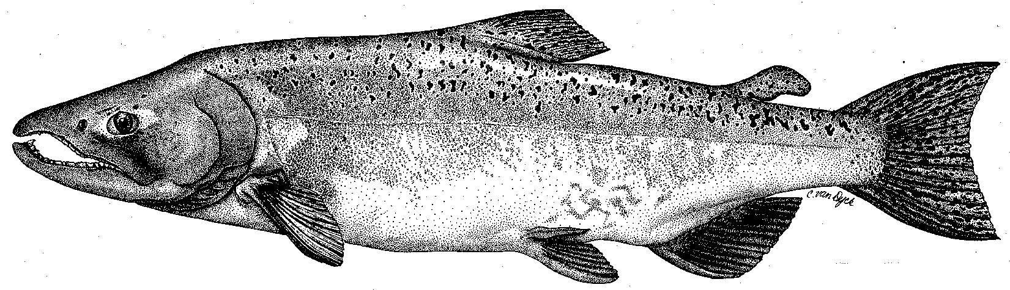

City & County of San Francisco
California Department of Fish & Game
U. S. Fish & Wildlife Service
333 East Canal Drive
Turlock, CA 95381-0949
Phone: (209) 883-8275
Fax: (209) 656-2180
Email: tjford@tid.org

TECHNICAL ADVISORY COMMITTEE MEETING
10 December 2009 at 9:30 AM
Turlock Irrigation District, Lunch Room (2nd floor)

Summary

1. Introduction and Announcements
- No fishery agencies or NGOs were present.

2. Administrative Items:

Review/Revise agenda – No changes

Approve notes from September meeting – No changes were identified. Notes for the last meeting are posted to the TRTAC website: http://tuolumnerivertac.com/

Items since last meeting – the handout listing the material posted at http://tuolumnerivertac.com/ was reviewed. Those included:

correspondences regarding the study plans for FERC required temperature modeling and instream flow studies, minimum flow coordination process for the 2009–2010 Fish Flow Year, Districts letter to CDFG responding on their August letter regarding 2008 Tuolumne River Diversion at the La Grange Powerhouse, the final report of the Presiding Judge on Interim Measures prior to relicensing, and transmittal to fishery agencies about the FERC required O. mykiss Monitoring Report due in January, 2010

the draft O. mykiss monitoring report, a recent report on the population genetic structure of Central Valley O. mykiss, final report and appendices on the March and July 2009 O. mykiss population size estimates, and the final temperature modeling and instream flow study plans with comments/responses

counting weir data and photos, thermograph data, basin monitoring newsletter, and current flow schedule

3. Monitoring/Reports: Several handouts were reviewed
- fall 2009 counting weir and flow data for Tuolumne and Stanislaus Rivers, including trend in salmon with adipose fin clips; CDFG required some Tuolumne weir panels to be removed temporarily because of concerns over spawning and counts downstream of the weir.
- preliminary CDFG salmon survey numbers (live, redds)
- Results of the 2008-09 O. mykiss and Chinook salmon snorkel surveys/population estimates were discussed, including observations of few fish downstream of Roberts Ferry Bridge during both the March and July surveys
- Flow and temperature trends from mid-June through August were reviewed
- draft Table of Contents for 2009 FERC Report was reviewed with a number of reports available on the TRTAC website (seine, snorkel, March/July 2009 Population estimate).
- Other winter monitoring plans: seining surveys, screwtrapping, March population estimate snorkel surveys, and FERC required winter adult O. mykiss tracking study (permit applications are submitted to fishery agencies)

4. Flow Operations:
- Ford identified that winter base flow were 225 cfs with 200 cfs after December 31
- approximately 7,000 AF of water remained to be allocated for the current Fish Flow Year through April 14, 2010
- variable summer flow operations averaged 105 cfs during the 75 cfs requirement period by additional releases depending upon temperature forecasts

5. Agency/NGO updates -- None

6. Additional items -- None

7. 2010 meeting dates – March 18, June 10, September 9, December 9

TRTAC Meeting Attendees

Name Organization

- Tim Ford TID/MID
- Robert Nees TID
- Noah Hume Stillwater
- Galileo Morales TID

