Tuolumne River Technical Advisory Committee
Don Pedro Project - FERC License 2299

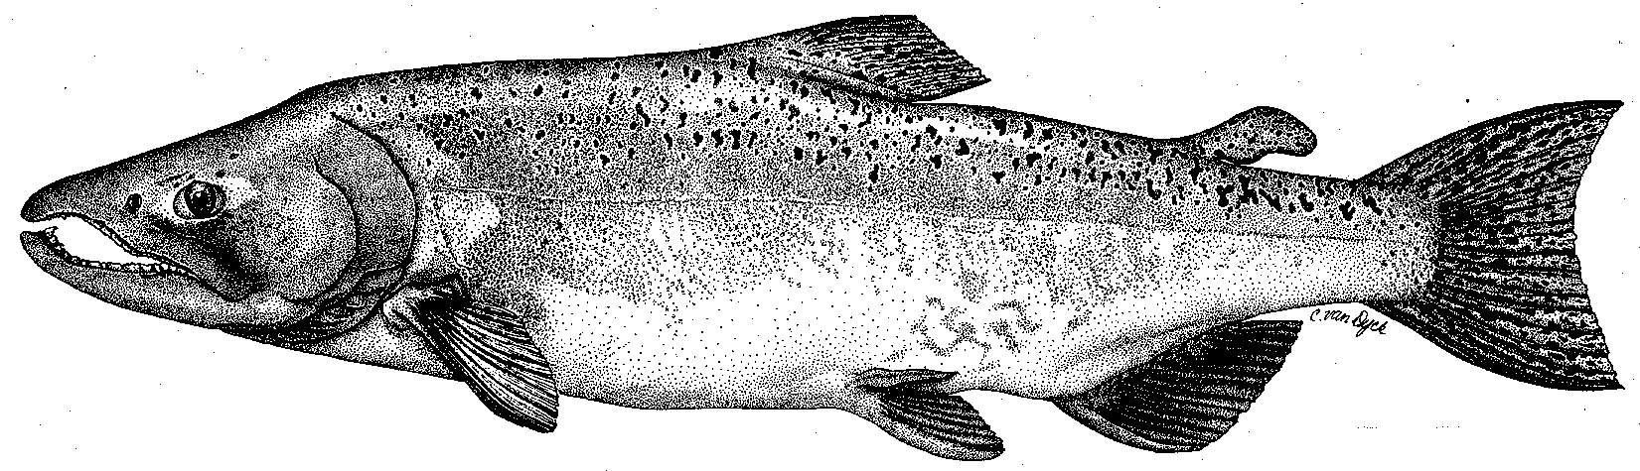

Modesto Irrigation District
Turlock Irrigation District
City & County of San Francisco
California Department of Fish & Game
U. S. Fish & Wildlife Service
333 East Canal Drive
Turlock, CA 95381-0949
Phone: (209) 883-8275
Fax: (209) 656-2180
Email: tjford@tid.org

TECHNICAL ADVISORY COMMITTEE MEETING
10 December 2009 at 9:30 AM
Turlock Irrigation District, Lunch Room (2nd floor)

DRAFT AGENDA

1. Introduction and Announcements

2. Administrative Items:

Review/revise agenda

Approve notes from Sep 2009 meeting

Items since last meeting

3. Monitoring/Reports:
- Fall run information – weir; river surveys
- O. mykiss reports posted
- Technical reports for 2009 FERC report
- Discuss winter monitoring and other studies

4. Flow Operations:
- Review status of flow schedule/watershed conditions

5. Agency/NGO updates

6. Additional items

7. Next meeting – Quarterly on 2nd Thursday: March 11, 2010

