Tuolumne River Technical Advisory Committee
Don Pedro Project - FERC License 2299

Modesto Irrigation District
Turlock Irrigation District
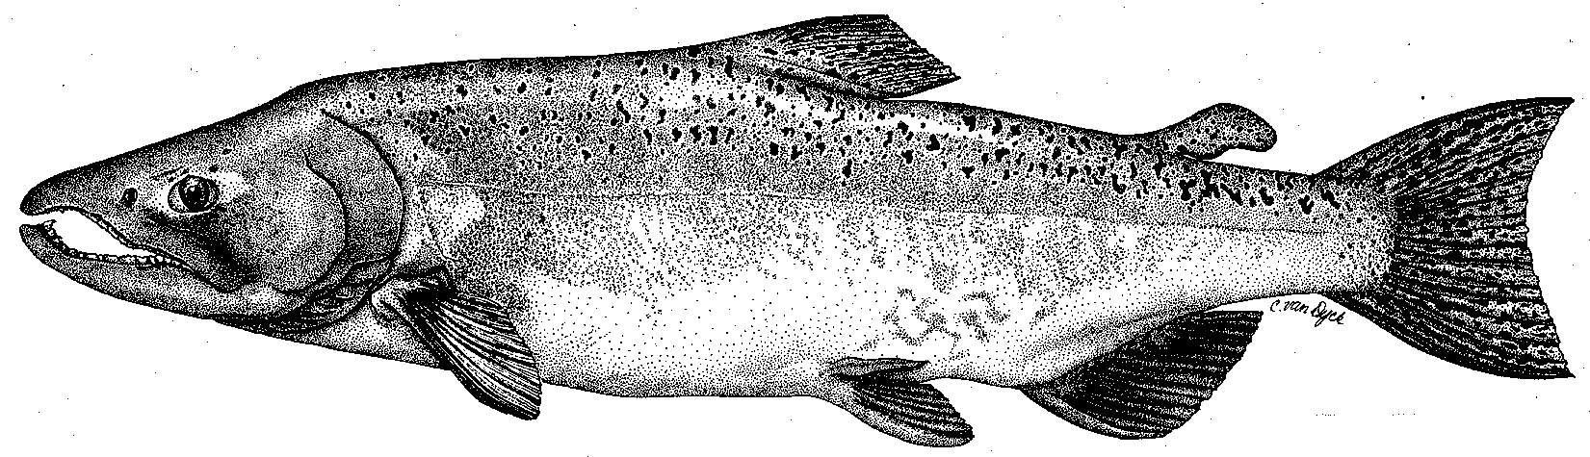

City & County of San Francisco
California Department of Fish & Game
U. S. Fish & Wildlife Service
333 East Canal Drive
Turlock, CA 95381-0949
Phone: (209) 883-8275
Fax: (209) 656-2180
Email: tjford@tid.org

TECHNICAL ADVISORY COMMITTEE MEETING
11 December 2008 at 9:30 AM
Turlock Irrigation District, Lunch Room (2nd floor)

Final Summary

1. Introduction and Announcements
- No fishery agencies were present.
- Jesse Roseman and Karlha Arias attended from the Tuolumne River Trust.

2. Administrative Items:

Review/Revise agenda – no changes

Review notes from 11SEP – no changes.

Items produced since last meeting – reviewed handout from Ford listing material posted at http://tuolumnerivertac.com/

3. Monitoring/Reports:
- Salmon run data - Ford provided initial low salmon run estimates for the San Joaquin tributaries. Expected higher returns following the 2005-2006 wet water years did not occur and Delta survival has been low for the past 5-6 years of VAMP studies. The group discussed straying and ocean survival influences. Sears mentioned a NMFS study that indicated up to 90% of ocean harvest was of hatchery origin and that in the Mokelumne up to 97% of the returns were of hatchery origin. Yoshiyama asked whether CDFG maintains planting records in the Merced River to examine production vs. returns and to examine ocean and other life history phases. Sears recommended otolith approaches to examine tributary specific rearing vs. in-Delta rearing as a means of pursuing tributary-specific vs. basin-wide management.
- Technical Reports for 2008 FERC Report. Ford provided a handout listing a draft Table of Contents for the 2008 FERC Report. Several of the technical reports were available on the TRTAC website (Seine, Screw Trap, July 2008 O. mykiss Population Estimate).
- Discussion of McBain & Trush Memo on evaluation of Peaslee Creek sediment inputs resulting from January-February 2008 runoff events. Study results were somewhat inconclusive due to similarity in fine sediment intrusion and low invertebrate metrics at the riffle immediately upstream of Peaslee Creek when compared to Bobcat Flat riffles downstream and also due to timing of assessment after spring pulse flow. Ford described additional sediment controls have been implemented which may reduce potential for 2009 events, but stated that the ultimate responsibility lies with agencies such as CVRWQCB, NMFS and CDFG. Masuda and Sears suggested reviewing redd distribution information from CDFG. It was also suggested the report be included in the 2008 FERC report.
- O. mykiss studies - the fishery agencies do not support sacrificial sampling for the otolith study. For the tracking study, the equipment system will be that used for the VAMP study. Planning is ongoing for the winter population estimate survey using snorkeling and electrofishing. Ford stated NMFS had recommended consideration of a weir on the Tuolumne for counting upmigrant O. mykiss.

4. Flow Operations:
- Ford provided a handout of the final flow schedule allocating 121,838 AF. Flow requirement will remain 150 cfs until next April.
- A discussion of dry year forecasting as it relates to final required annual flow volume followed. Ford provided a handout showing the change from April 1 forecasted volumes at 50% and 90% exceedence to the final volume for dry years of 2002, 2004, 2007, and 2008. In those years the 90% forecast was the better estimator of final volume. For 2004 and 2008, the final volume was even less than the April 1 90% forecast, demonstrating the importance of anticipating extreme conditions in establishing spring pulse flow allocations in drier water year types.

5. Restoration :
- A December 11 update handout by Wilton Fryer was briefly reviewed
- CDFG continues to withhold nearly $470,000 in reimbursement to TID for invoices from 2007 for work done on the Gasburg Creek Fine Sediment Project.
- CALFED grant funds for other TRTAC projects have still not been provided by CDFG: the Gravel Addition Project (about $3.9 million) and Mining Reach Project (about $10.8 million). CDFG Central Region (Region 4) did not support the Gravel Addition Project at a November 20 CALFED Amendment Committee meeting.

6. Agency/NGO updates
- TRT
  - Roseman/Arias discussed acquisition funds for the Dos Rios project and mentioned it as a possible State Park. They are currently considering whether to manage the property for Endangered Species or for public access. River Partners would hold title to the property and has a Draft Restoration Plan available.
- USFWS
  - Although USFWS were not present at the meeting, Yoshiyama raised concerns regarding the interpretation of the recent USFWS overbank flow analysis report by Mark Gard. In particular, he suggested analysis of the locations and amounts of floodplain habitat should be considered. The USFWS analysis stops at Empire and does not encompass floodplain west of Modesto. Ford stated that the Districts were still reviewing the report. Much of the base information used for the report had been developed for prior fluctuation assessments.

7. Additional items
- None.

8. 2009 meeting dates - March 12, June 11, September 10, december 10

TRTAC Meeting Attendees

Name Organization

- Tim Ford TID/MID
- Robert Nees TID
- Roger Masuda TID
- Walter Ward MID
- Ron Yoshiyama CCSF
- Bill Sears SFPUC
- Noah Hume Stillwater Sciences
- Jesse Roseman Tuolumne River Trust
- Karlha Arias Tuolumne River Trust

