Tuolumne River Technical Advisory Committee
Don Pedro Project - FERC License 2299

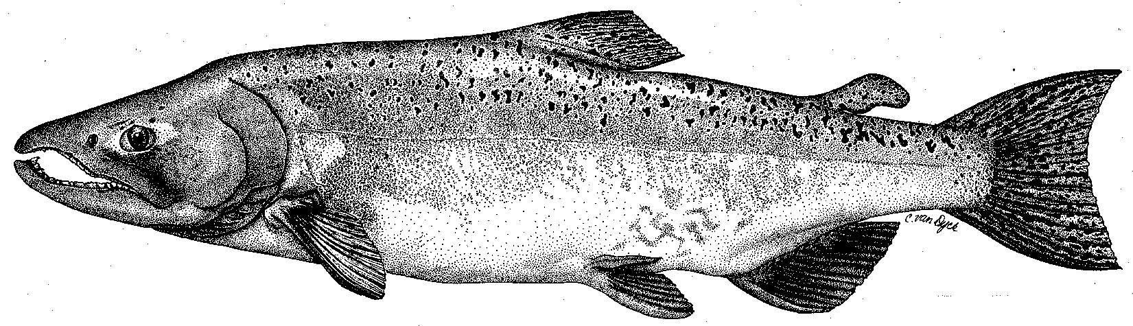

Modesto Irrigation District
Turlock Irrigation District
City & County of San Francisco
California Department of Fish & Game
U. S. Fish & Wildlife Service
333 East Canal Drive
Turlock, CA 95381-0949
Phone: (209) 883-8275
Fax: (209) 656-2180
Email: tjford@tid.org

TECHNICAL ADVISORY COMMITTEE MEETING
11 December 2008 at 9:30 AM
Turlock Irrigation District, Lunch Room (2nd floor)

DRAFT AGENDA

1. Introduction and Announcements

2. Administrative Items:

Review/revise agenda

Approve notes from September 2008 meeting

Items since last meeting

3. Monitoring/Reports:
- Status of salmon run data
- Technical Reports for 2008 FERC Report
- Discuss 2009 salmon and other studies
- Discuss 2009 trout studies: population estimates, tracking study, etc.

4. Flow Operations:
- Review status of final basin index, annual fish flow volume, and flow schedule

5. Restoration: Review status of TRTAC projects

6. Agency/NGO updates

7. Additional items

8. 2009 meeting dates – Quarterly on 2nd Thursday: March 12, June 11, September 10, December 10

