Tuolumne River Technical Advisory Committee
Don Pedro Project - FERC License 2299

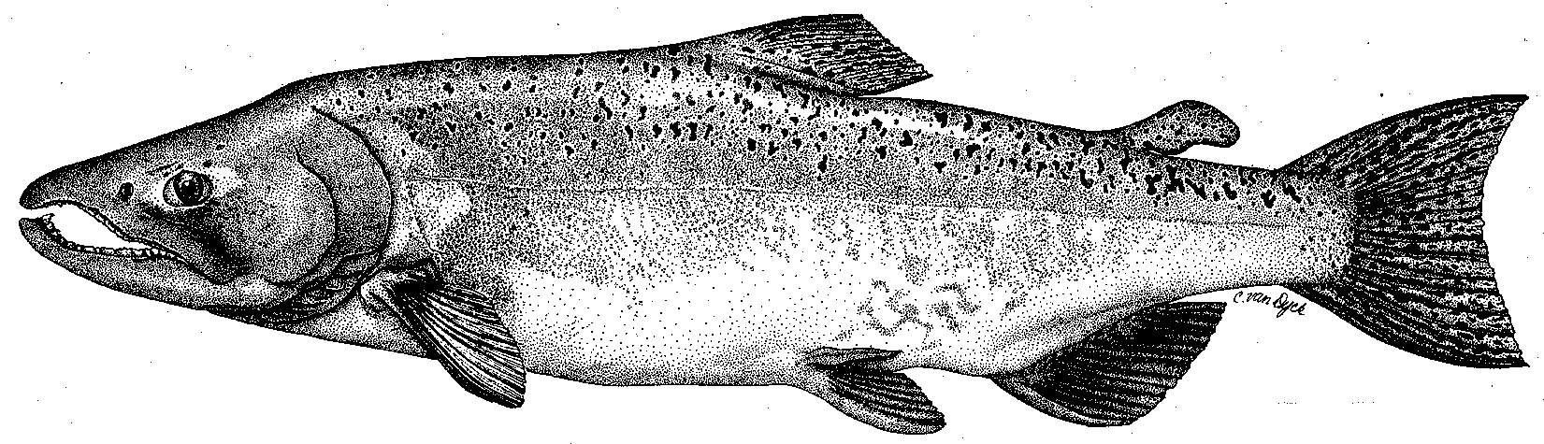

Modesto Irrigation District
Turlock Irrigation District
City & County of San Francisco
California Department of Fish & Game
U. S. Fish & Wildlife Service
333 East Canal Drive
Turlock, CA 95381-0949
Phone: (209) 883-8275
Fax: (209) 656-2180
Email: tjford@tid.org

TECHNICAL ADVISORY COMMITTEE MEETING

13 December 2007
9:30 AM
Turlock Irrigation District, Lunch Room (2nd floor)

Draft Summary

1. Introduction
- No agencies or NGOs were present – FWS had called to say they could not attend
- Beth Chasnoff is new staff with Stillwater Sciences

2. Comments on draft agenda - none

Sep meeting summary was approved with minor wording change to Item 5

3. General Updates

Items since last meeting: the material list was reviewed

Data/report status

2007 FERC report will have usual technical reports from monitoring programs (screw traps, seine/snorkel, thermographs, spawning survey)

Invertebrate samples from 2005 and 2007 will be ID’ed and a report included if completed in time (by late March)
- Other reports may be included as available

Seine/snorkel report posted to website and available for comment

- Agency and NGO updates
  - None present

- Monitoring update
- Nothing heard from CDFG since March2007 on TRTAC monitoring grant
- Snorkel survey was done in September
- Spawning surveys through November by CDFG indicate very low runs in all three San Joaquin tributaries
- Anticipate for now continuation of 2007 monitoring activities in 2008, depending on pending FERC determination; likely that any acoustic study would start in 2009 due to extended lead time involved

- Restoration and gallery project status
  - Handout of updated TRTAC project status from Fryer (TID) was reviewed:
    - Gasburg Project still has several issues as CDFG removed amendment approval from CALFED meeting agenda in Nov2007; planting by CDFG may not be done as a result
    - Gravel addition project: nothing new since CDFG removed amendment approval from the CALFED meeting agenda in May2007.
    - Warner-Deardorff and Ruddy Reach: nothing new; CDFG has not responded to funding request submitted in May2007
- Gallery project could begin in 2010 at earliest and operation may depend on several factors

4. River operations and forecasts

Current minimum flow schedule is 150 cfs through mid-April

No pulse flow was allocated by fishery agencies; high pulses went made on Stanislaus and Merced Rivers

Ford provided some handouts

Precipitation to date is below average, mainly due to very dry November
  - Dec 1 DWR basin index forecast was critical at 50%

5. Additional items
- Some discussion of Water Temperature Model – status of progress will be checked

6. 2008 meeting dates
- Same as 2007, 2nd Thursday of Mar, Jun, Sep, Dec starting at 9:30 AM at TID

FERC 2299 TRTAC Meeting

13 December 2007

Name Organization

Tim Ford TID/MID
Roger Masuda (phone) TID
Walter Ward MID
Bill Sears CCSF
Ron Yoshiyama CCSF
Noah Hume Stillwater Sciences
Beth Chasnoff Stillwater Sciences

