Tuolumne River Technical Advisory Committee
Don Pedro Project - FERC License 2299

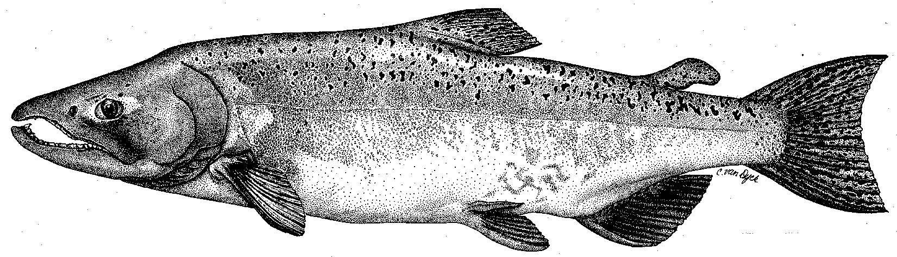

Modesto Irrigation District
Turlock Irrigation District
City & County of San Francisco
California Department of Fish & Game
U. S. Fish & Wildlife Service
333 East Canal Drive
Turlock, CA 95381-0949
Phone: (209) 883-8275
Fax: (209) 656-2180
Email: tjford@tid.org

TECHNICAL ADVISORY COMMITTEE MEETING

13 December 2007
9:30 AM
Turlock Irrigation District, Lunch Room (2nd floor)

DRAFT AGENDA

1. Introduction

2. Comments on agenda; approve prior meeting summary (at http://tuolumnerivertac.com/)
3. General Update

Items since last meeting

Data/report status
- Agency/NGO updates
- Monitoring update

Restoration and gallery project status
4. River operations and forecasts
5. Additional items
6. 2008 meeting dates

