Tuolumne River Technical Advisory Committee
Don Pedro Project - FERC License 2299

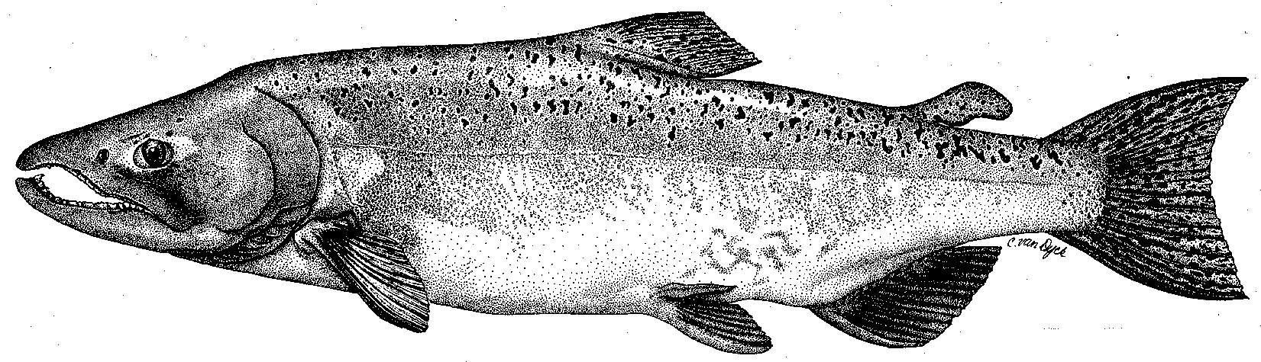

Modesto Irrigation District
Turlock Irrigation District
City & County of San Francisco
California Department of Fish & Game
U. S. Fish & Wildlife Service
333 East Canal Drive
Turlock, CA 95381-0949
Phone: (209) 883-8275
Fax: (209) 656-2180
Email: tjford@tid.org

TECHNICAL ADVISORY COMMITTEE MEETING

14 September 2006
9:30 AM
Turlock Irrigation District, Lunch Room (2nd floor)

Draft Summary

1. Introduction
- Comments on draft agenda and meeting summary – none; Bouchers could not attend due to work at Bobcat Flat

2. Items since 08Jun meeting

Review material list and meeting summary – no comments
3. Updates

Status of data/reports

Ford reviewed some recent updates to the website http://tuolumnerivertac.com/

handouts were provided from website listing the TRTAC meetings and posted documents for 2004-2005

- Agency and NGO updates (DFG updates in monitoring and restoration below)
  - TRT (Koepele) reported (1) tree planting and canoe trips are scheduled, (2) about 80 people attended recent Day on the River event, and (3) receiving CALFED grant with Great Valley Museum for environmental education

- Monitoring update
- DFG is recording GPS data for riffle location (started annually in 2000) and changes due to high flows in preparation for spawning surveys;
- discussion of riffle ID, tracking changes over time, how to make data available, still needs further discussion;
- Blakeman reported there was good fishing for rainbow trout;
- Jen Vick is doing some Bobcat Flat monitoring, including collection of marked rocks;
- DFG may have SJR temperature data that could substitute for missing TID/MID Gardner Cove data from last download (available on TRTAC website)

- Restoration update
  - handout of TRTAC project status from Fryer;
  - John Stella (UC Berkeley/SWS) reviewing valley-wide age distribution of riparian vegetation and relation of flow to recruitment;
  - Battistoni had a 01Jul tech. coordination meeting that included fine sediment and Warner-Deardorff projects;
  - channel repairs at Ruddy site are starting; DFG may do gravel additions in 2007 with 4-pumps funding

4. River operations, flow schedule, and forecasts

Discussed draft flows for Sep-Oct including those sent by TID to Marston who is working on basinwide flows contributing to flow in SJR at Vernalis below the Stanislaus River;

La Grange flows will be provided from MID side during 09-14Oct dam inspection and Tuolumne pulse flow will follow, with anticipation of higher flows being on Stanislaus and Merced Rivers in Oct;

45-day fluctuation limitation period will still be 17Oct-30Nov.

5. General discussion and additional items
- Mitchell discussed the post-10 year report process with FERC’s Taylor;
- letter will be drafted by Mitchell to FERC prior to 25Sep about extending the process and several meeting dates will be set

6. Next meetings and topics:
- TRTAC on 14Dec
- CALFED Science Conference in Sacramento during week of 23Oct

FERC 2299 TRTAC Meeting

14 September 2006

Name Organization

Tim Ford TID/MID
Debbie Liebersbach TID
Walt Ward MID
Ron Yoshiyama CCSF
Patrick Koepele TRT
John Battistoni DFG
Tim Heyne DFG
Dean Marston DFG
Dale Mitchell DFG
Dennis Blakeman DFG
Noah Hume Stillwater Sciences
Jennifer Vick McBain & Trush

