Tuolumne River Technical Advisory Committee
Don Pedro Project - FERC License 2299

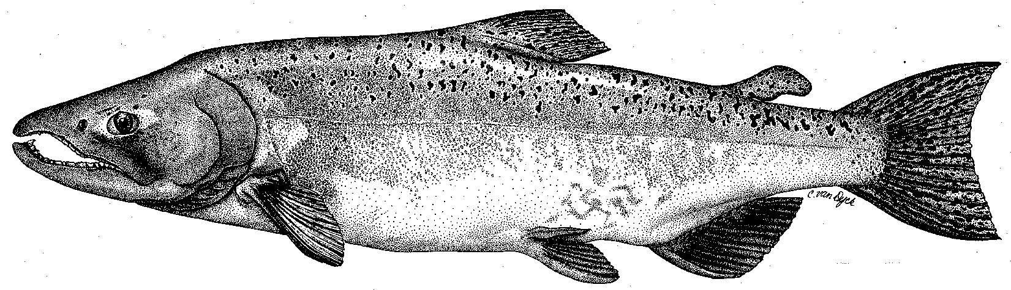

Modesto Irrigation District
Turlock Irrigation District
City & County of San Francisco
California Department of Fish & Game
U. S. Fish & Wildlife Service
333 East Canal Drive
Turlock, CA 95381-0949
Phone: (209) 883-8275
Fax: (209) 656-2180
Email: tjford@tid.org

TECHNICAL ADVISORY COMMITTEE MEETING

14 September 2006
9:30 AM
Turlock Irrigation District, Lunch Room (2nd floor)

DRAFT AGENDA

1. Introduction
- Comments on draft agenda and meeting summary

2. Items since 08Jun meeting

Review material list
3. Updates

Status of data/reports
- Agency and NGO updates
- Monitoring update
- Restoration update

4. River operations, flow schedule, and forecasts
5. General discussion and additional items
6. Next meetings and topics:
- TRTAC on 11Dec
- Others?

