Tuolumne River Technical Advisory Committee
Don Pedro Project - FERC License 2299

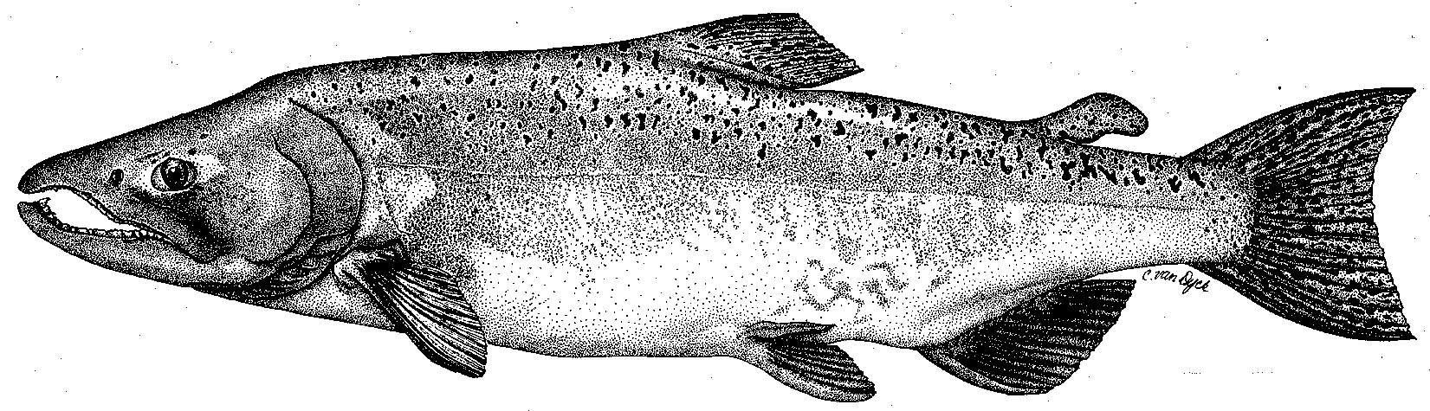

Modesto Irrigation District
Turlock Irrigation District
City & County of San Francisco
California Department of Fish & Game
U. S. Fish & Wildlife Service
333 East Canal Drive
Turlock, CA 95381-0949
Phone: (209) 883-8275
Fax: (209) 656-2180
Email: tjford@tid.org

TECHNICAL ADVISORY COMMITTEE MEETING
September 25, 2003, 9:30 a.m.
Turlock Irrigation District, Lunch Room (2nd floor)

DRAFT AGENDA

1. Introduction
- Comments on draft agenda
- Correspondence since last meeting
2. ACTION ITEMS:
- Flow schedule
- Spawning survey monitoring
3. General FSA Update:

FSA/Order activity and expense tracking, subgroup activity, and report status

VAMP, NGO, and agency updates

Monitoring

River operations and flow schedule

Restoration
      - Planning and implementation
      - Project monitoring
      - Other restoration projects and proposals
4. Additional items
5. Next meeting and topics

