Tuolumne River Technical Advisory Committee
Don Pedro Project - FERC License 2299

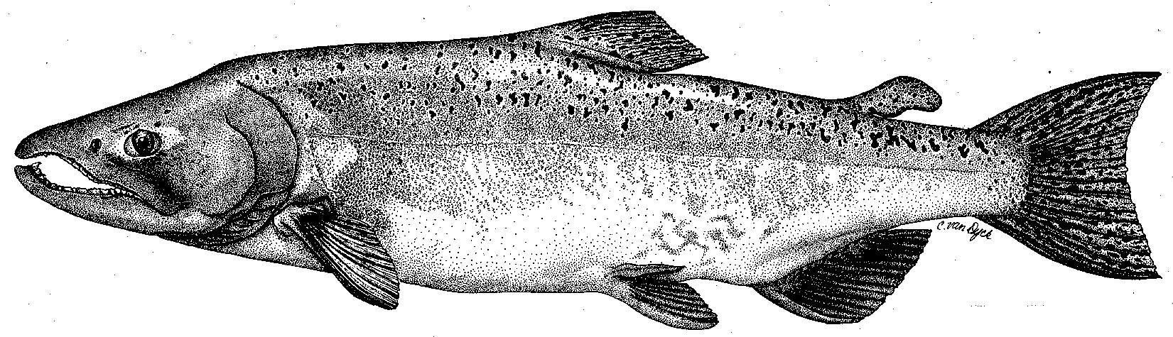

Modesto Irrigation District
Turlock Irrigation District
City & County of San Francisco
California Department of Fish & Game
U. S. Fish & Wildlife Service
333 East Canal Drive
Turlock, CA 95381-0949
Phone: (209) 883-8275
Fax: (209) 656-2180
Email: tjford@tid.org

TECHNICAL ADVISORY COMMITTEE MEETING

08 June 2006
9:30 AM
Turlock Irrigation District, Lunch Room (2nd floor)

Draft Summary

1. Introduction
- Comments on draft agenda and meeting summary - none

2. Items since 09Mar meeting

Review material list – no comments
3. Discussion of monitoring and conceptual models – Mesick still not able to present model, but stated it would attempt to summarize what is known and not known and recommend what to investigate; DFG presently is reviewing his conceptual model.
4. General Update

Hardcopies and CD’s of 2005 annual report to FERC were handed out at meeting
- Agency and NGO updates: FOT – Bouchers could not attend due to ongoing restoration work at Bobcat Flat; TRT – Patrick is working part-time at Columbia College; Elizabeth Holtz was introduced and she will work out of Modesto office (new location at 829 13th St.); FWS – Mesick reviewing critique of DFG salmon model, working on review of fall flows, and screw trap trend analysis.
- Monitoring update – Hume reported that ID of 2005 invertebrate samples was in progress; Ford indicated that further monitoring (except thermographs) was on hold pending resolution of CALFED grant; Blakeman had no information on grant status, but agreed to check on availability and parameters of Don Pedro profiles gathered for Dotan’s basin temperature model; Nees reported that a letter regarding the grant was to have been provided by the DFG regional office.

River operations and forecasts – Ford briefly discussed a recent e-mail exchange with A. Boucher on flow operations; flows were in the process of coming down.
5. Additional items – Restoration: Handout of project status from Fryer; Ruddy Mining Reach Project may not proceed and could affect the Warner-Deardorff Project; SRP 9 predation study was done in May with a report expected by the end of June; SRP 10 does not have funding for construction; Blakeman reported that the next DFG gravel addition would now be in 2007.
6. Next meetings and topics:
- Next TRTAC meeting is scheduled for 14Sep.

FERC 2299 TRTAC Meeting

08 June 2006

Name Organization

Tim Ford TID/MID
Robert Nees TID
Roger Masuda (phone) TID
Bill Johnston MID
Ron Yoshiyama CCSF
Patrick Koepele TRT
Elizabeth Holtz TRT
Dennis Blakeman DFG
Carl Mesick FWS-AFRP
Noah Hume Stillwater Sciences

