Tuolumne River Technical Advisory Committee
Don Pedro Project - FERC License 2299

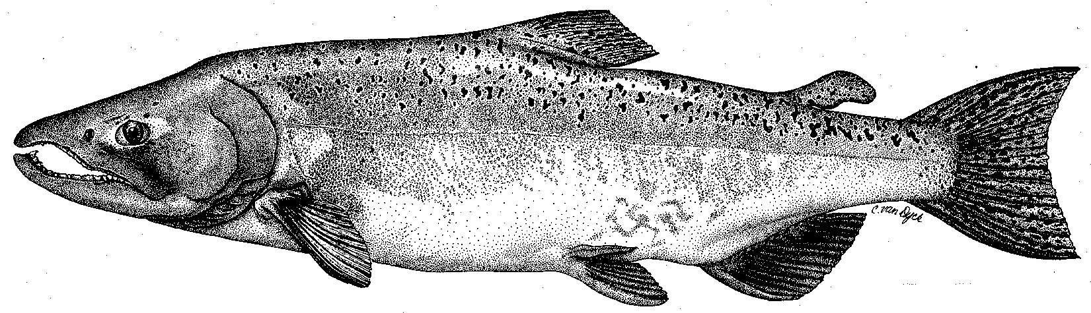

Modesto Irrigation District
Turlock Irrigation District
City & County of San Francisco
California Department of Fish & Game
U. S. Fish & Wildlife Service
333 East Canal Drive
Turlock, CA 95381-0949
Phone: (209) 883-8275
Fax: (209) 656-2180
Email: tjford@tid.org

TECHNICAL ADVISORY COMMITTEE MEETING

08 March 2007
9:30 AM
Turlock Irrigation District, Lunch Room (2nd floor)

Draft Summary

1. Introduction
- Comments on draft agenda and prior meeting summary – none

2. Items since Dec2006 meeting

Comments on material list – the listed items were reviewed
B. Status of 2005 TRTAC monitoring grant – DFG had no new information

3. Updates

Status of data/reports, including annual report

Ford provided draft annual report listing; 2006 report from DFG will be out soon; CWT update will update all tributary survival results and add first summary of SJR reaches

- Agency and NGO updates
  - FOT – see Boucher items in D below
  - DFG – see items in C below
  - FWS had no update – Kim Webb is Acting Project Leader and available by e-mail

- Monitoring update
- DFG reported estimate of 625 salmon in fall run – lower than in Stanislaus and Merced runs
- Ford provided handouts on salmon catch and size from the Waterford RST and the seining
- DFG has no plans to conduct lower RST operation this year

- Restoration update
  - Handout of updated TRTAC project status from Fryer (TID) was briefly reviewed
  - Boucher reported: State Parks is looking into acquiring land, incl. TR Resort; Grayson River Ranch active work is complete – monitoring report(s) will be later this year, but not in time for report to FERC; Bobcat Flat is having bird boxes installed by Lee Morris, an osprey nest platform is planned, and purchase of some of Arthur parcel is underway
  - Next TR Coalition meeting is 15 March

4. River operations and forecasts – FERC/VAMP schedules

Ford provided handout on FSA flow schedule/volumes by year type – dry year at 90% exceedence forecast; volume likely to be in range of 117,000-143,000 AF
- Discussion on potential to shift water for spring pulse, but no decision – some concern raised about delta pump impacts
- VAMP may begin on 22 April; barrier at Head of Old River not expected; study is planned with 1000 smolts with acoustic tags;

5. Review of 2007 FERC Study Plan Proposal
- Nees introduced subject, then Wilcox led review of plan elements
- Li inquired about Section 10 permit issues
- FWS, DFG, and NMFS not prepared to provide any additional comments; Li stated he would review proposal
- Boucher: stated that FSA did not require Districts to implement ten projects, although they needed to be diligent in seeking funds; other NGO comments addressed most of their issues; concerned about adequacy of spring flows to mirror natural patterns and no additional flow commitment
- Ford stated existing spring flows vary by year type; winter pulses are experimental for fry movement
- Handout comparing study elements of Districts’ proposal and Agency Limiting Factors Analysis
- Nees stated Districts are reviewing existing comments as part of submittal to meet FERC timeline

6. Additional items
- TID infiltration gallery at Geer Road may become operational in 2009
- Water quality was discussed; what is status of monitoring in basin? Boucher noted several E. coli reports are being done, would like WQ info. on TRTAC website, is interested in monitoring downstream of Geer Road, and is concerned about possible impacts from feedlot near Peaslee Creek off Lake Road.

7. Next meetings and topics:
- TRTAC on 14Jun, 13Sep, 13Dec; all start at 9:30 AM at TID

FERC 2299 TRTAC Meeting

08 March 2007

Name Organization

Tim Ford TID/MID
Robert Nees TID
Roger Masuda TID
Debbie Leibersbach TID
Jeanie Hinds TID
Bill Johnston MID
Ron Yoshiyama CCSF
Dennis Blakeman DFG
Rick Burmester USFWS
Stacy Li NMFS
Noah Hume Stillwater Sciences
Scott Wilcox Stillwater Sciences
Allison Boucher FOT

