Tuolumne River Technical Advisory Committee
Don Pedro Project - FERC License 2299

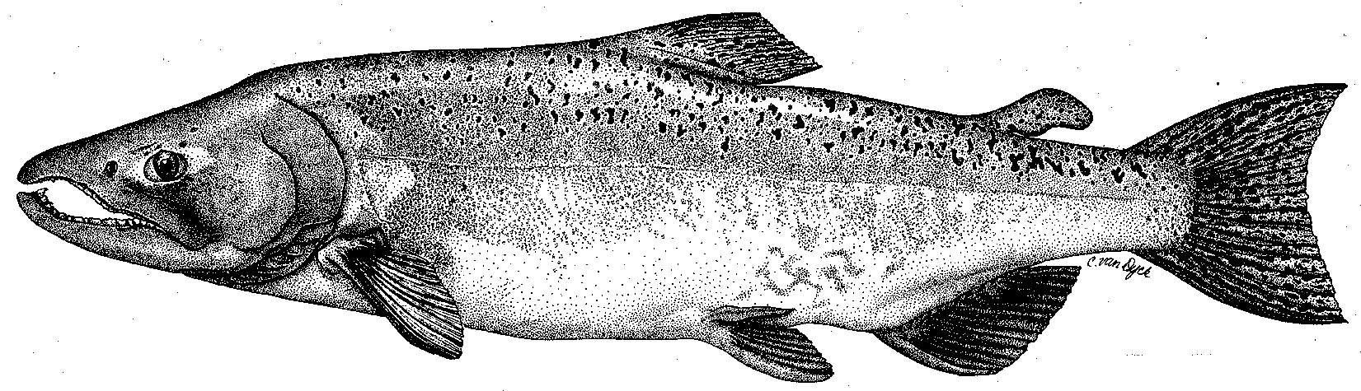

Modesto Irrigation District
Turlock Irrigation District
City & County of San Francisco
California Department of Fish & Game
U. S. Fish & Wildlife Service
333 East Canal Drive
Turlock, CA 95381-0949
Phone: (209) 883-8275
Fax: (209) 656-2180
Email: tjford@tid.org

TECHNICAL ADVISORY COMMITTEE MEETING

08 March 2007
9:30 AM
Turlock Irrigation District, Lunch Room (2nd floor)

DRAFT AGENDA

1. Introduction - Comments on draft agenda and prior meeting summary

2. Items since Dec2006 meeting

Review material list

Status of TRTAC monitoring grant approved for funding in 2005
3. General Update

Data and report status, including Annual Report to FERC
- Agency and NGO updates
- Monitoring update – Spawning run, ongoing and planned 2007 activities

Restoration status
4. River operations and forecasts – FERC/VAMP schedules
5. Review of 2007 FERC Study Plan Proposal
6. Additional items
7. Next meeting and topics:
- 14 June at TID

