Tuolumne River Technical Advisory Committee
Don Pedro Project - FERC License 2299

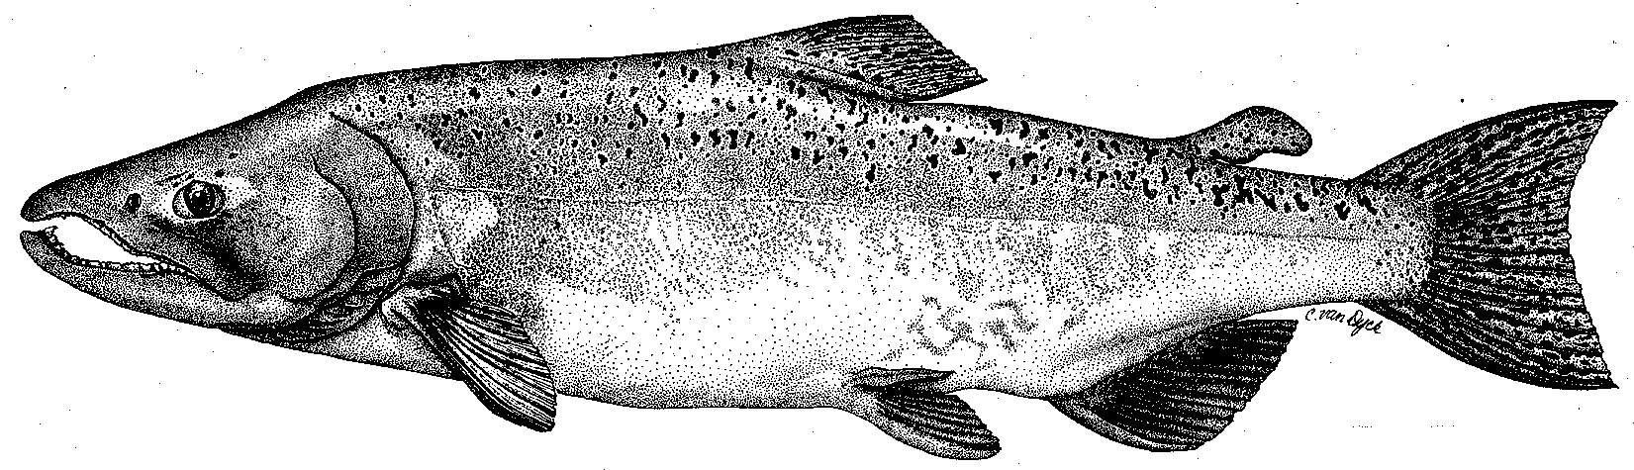

Modesto Irrigation District
Turlock Irrigation District
City & County of San Francisco
California Department of Fish & Game
U. S. Fish & Wildlife Service
333 East Canal Drive
Turlock, CA 95381-0949
Phone: (209) 883-8275
Fax: (209) 656-2180
Email: tjford@tid.org

TECHNICAL ADVISORY COMMITTEE MEETING

09 March 2006
9:30 AM
Turlock Irrigation District, Lunch Room (2nd floor)

Draft Meeting Summary

1. Introduction
- Comments on draft agenda and meeting summary - none

2. Items since 09Feb meeting

Review material list – no comments

Update on CALFED-funded monitoring draft workplans: Hume provided 3 handouts on that were reviewed – budget section was not available yet; discussion of reporting timelines, grant/project manager(s) and administration funding; Task 4-10 (avian surveys) has new material from PRBO; there was extended discussion of the angling survey and what types of samples might be taken; Action – Vick will provide the files for comments that are due back to her by 24Mar.
3. Discussion of monitoring, website, flow experiments, conceptual models – Koepele asked about the status of topics in Nov2005 meeting (including monitoring elements, flow schedule process, study plans for new funding, TRTAC process); Action – Ford will provide a status listing of discussion items since Sep2005 meeting by the Apr2006 meeting; Action - spring predation proposal (handout) comments due to SWS by 17Mar; Ford provided a handout of pages from the initial website developed by SP Cramer (only some pages have information yet); plan is to include all TRTAC materials http://www.tuolumnerivertac.com/; Action - Ford will resume work on the website in April – send any comments/material to him
4. General Update

Data and report status, including Annual Report: 2005 Spawning survey and 2005 screw trap reports should be out next week; Ford asked DFG to provide spreadsheet files at earliest opportunity so work on Summary Update reports can proceed. Plan is for e-filing by end of month with hardcopies to be produced in April
- Agency and NGO updates: FOT – Bobcat Flat tour on 19Mar, Grayson Ranch work mostly complete (contract expires in Sep); new Ceres Park plans to leave bank riprap (input can still be made to Ceres); Bobcat Flat planting will be made this spring (or summer), ideally with lower flows; TPT – more planting days at Big Bend; DFG- Rhiana Lee is new employee with 4-pumps funding to work on restoration projects.
- Monitoring update – nothing to add to already distributed material on seine and screw trap sampling.

River operations and forecasts – current flows are near 5000 cfs with more rain in forecast; Hickman spill is in use and Faith Home spill will start; Don Pedro is about 2 feet below flood control level so inflows will be passed through near end of April when allowable storage increases; so far not as wet as last year and snowpack increases at higher elevations; VAMP briefly discussed – Old River barrier not likely due to delta smelt concerns and current prospect for higher flows
5. Additional items: no new update on restoration projects since Feb meeting; discussion of ownership status of parcels upstream of Basso Bridge – Vaughn parcels have been acquired by State; questions about status of Ingalls parcels – may need to check with Assessors office; no further DFG action on 7-11 turbid spill since analysis of water samples indicated sediment levels were not too high – owner also plans revised disposal of outflow; discussion of need to address trespass grazing above Basso Bridge
6. Next meetings and topics:
- 06Apr Subgroup at MID: conceptual models/overall topic review – results go back to full TRTAC
- 08Jun at TID
- Others? – none selected at this time, need for May meeting will be considered in April.

FERC 2299 TRTAC Meeting

09 March 2006

Name Organization

Tim Ford TID/MID
Robert Nees TID
Debbie Liebersbach TID
Roger Masuda TID
Bill Johnston MID
Ron Yoshiyama CCSF
Patrick Koepele TRT
Allison Boucher FOT
Tim Heyne DFG
Dennis Blakeman DFG
Carl Mesick FWS-AFRP
Steve Walser CRRF
Noah Hume Stillwater Sciences
Jen Vick (phone) McBain & Trush

