Tuolumne River Technical Advisory Committee
Don Pedro Project - FERC License 2299

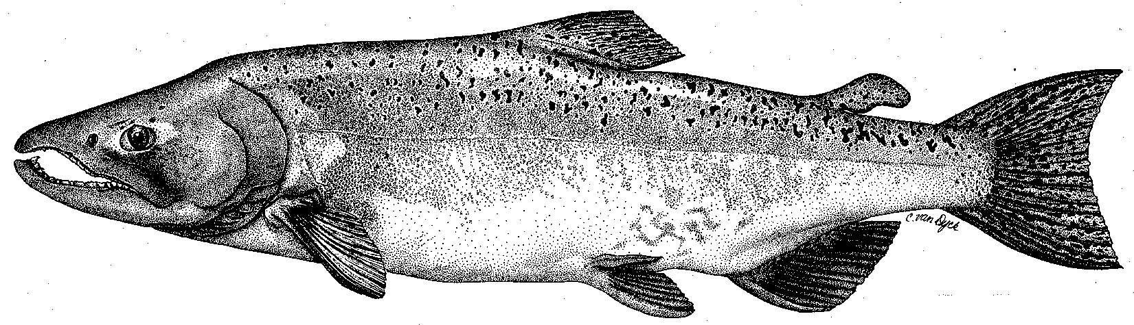

Modesto Irrigation District
Turlock Irrigation District
City & County of San Francisco
California Department of Fish & Game
U. S. Fish & Wildlife Service
333 East Canal Drive
Turlock, CA 95381-0949
Phone: (209) 883-8275
Fax: (209) 656-2180
Email: tjford@tid.org

TECHNICAL ADVISORY COMMITTEE MEETING

09 March 2006
9:30 AM
Turlock Irrigation District, Lunch Room (2nd floor)

DRAFT AGENDA

1. Introduction
- Comments on draft agenda and meeting summary

2. Items since 09Feb meeting

Review material list

Update on CALFED-funded monitoring draft workplans
3. Discussion of monitoring, website, flow experiments, conceptual models
4. General Update

Data and report status, including Annual Report
- Agency and NGO updates
- Monitoring update

River operations and forecasts
5. Additional items
6. Next meetings and topics:
- 06Apr Subgroup at MID: conceptual models
- 08Jun at TID:
- Others?

