Tuolumne River Technical Advisory Committee
Don Pedro Project - FERC License 2299

Modesto Irrigation District
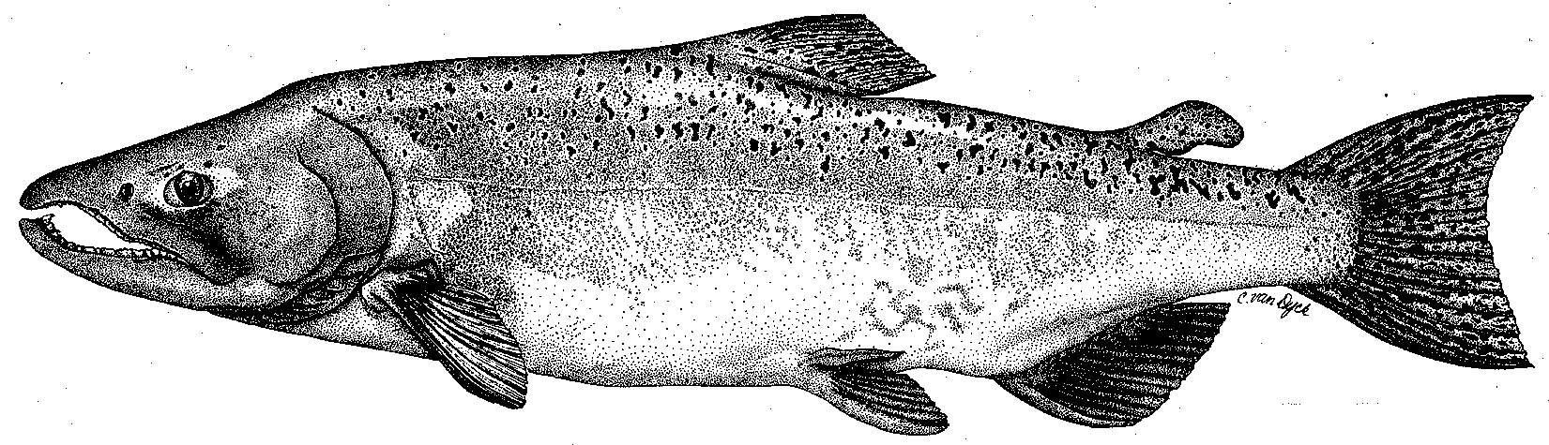

Turlock Irrigation District
City & County of San Francisco
California Department of Fish & Game
U. S. Fish & Wildlife Service
333 East Canal Drive
Turlock, CA 95381-0949
Phone: (209) 883-8275
Fax: (209) 656-2180
Email: tjford@tid.org

TECHNICAL ADVISORY COMMITTEE
MEETING MINUTES of
25 September 2003
DRAFT

1. AGENDA & PRIOR MINUTES
- No comments on draft minutes from meeting of 24 June 2003.
- Correspondence since last meeting:
    - Reviewed list of items
    - The August letter from FERC to the Districts requested several items regarding rainbow trout and steelhead (handout).
    - There is a new bridge proposed for a Faith Home/Claus Road connection across the river between Santa Fe and Mitchell Roads.

2. ACTION ITEMS:
- Summer Flow Schedule: This has been a warmer than average summer so many of the days have been at the higher 235 cfs requirement in the two-step schedule. At the end of the season there will be a review of thermograph data to see effects on water temperature profile in the upper reach of the river from varying the flows about 40 cfs. In addition, there will be consideration of updating the existing model from a 5-day average to a daily time step.
- Fall Flow Schedule: Given the hot temperatures, low DO situation in the Stockton ship channel, past water year v. fish arrival date information, and the timing for the barrier installation at the head of Old River, it was agreed to start the fall attraction flow on 16 October and use a series of decreasing flow steps. The steps will run for 5 days at flows of 450 cfs, 350 cfs, and 250 cfs.
- Monitoring: There was a discussion of how the current snorkel survey examines various habitats and about monitoring of macroinvertebrates. The TRTAC agreed to fund assisting DFG with the fall spawning surveys. Estimated cost should be less than $20,000.

- GENERAL INFORMATION:
- Ford reviewed TRTAC monitoring and restoration project spending status (handout).
- Agency and NGO activities. DFG is still working on their reports. The TRT is proposing a project for funding by the Wildlife Conservation Board regarding improving habitat on riparian lands in the La Grange area, including stockpiling of spawning aggregates as part of floodplain recontouring. This proposal is independent of the current DFG and TRTAC projects for gravel infusion at spawning riffles in the same reach of the river (handout). FOT (Boucher) is relocating to Stockton. They suggest mitigation funds as part of the Hetch Hetchy Project expansion be applied to the lower river.
- Monitoring: Studies are underway to evaluate potential mercury contamination issues from use of tailings materials for restoration work. The study is focusing on the Merced River tailings at this time. The RWQCB is looking at any use of tailings to include remediation of industrial wastes.
- Restoration Project Updates.
    - Wilton Fryer discussed a handout summarizing the status of the TRTAC projects.
    - There was a general discussion of riffle designs and implementation that will be a part of the final Course Sediment Management Plan developed by McBain & Trush for the TRTAC. FOT and NOAA Fisheries desire to have holding habitat for steelhead included in the designs for riffle rehabilitation above the Mining Reach projects. They are asking for changes in riffle length, undulations along the riffle, thalweg pools, and monitoring programs to evaluate the effectiveness of such changes on steelhead. There was reference to work being done on the Stanislaus by Carl Mesick.

4. ADDITIONAL ITEMS:
There is a new nonprofit NGO group with Steve Walser and Carl Mesick titled California Rivers Restoration Fund that could become active on Tuolumne River issues.

5. NEXT MEETING & TOPICS:
The next meeting was set for 17 December 2003 starting at 0930 in the TID upstairs conference room.

FERC 2299 TAC Meeting

25 September 2003

Name Organization

Tim Ford TID/MID

Wilton Fryer TID

Patrick Koepele TRPT

Jeff McLain USFWS

Allison Boucher FOTT

Ron Yoshiyama CCSF

Noah Hume Stillwater Sciences

Dean Marston DFG

Tim Heyne DFG

Madelyn Martinez NMFS

