Tuolumne River Technical Advisory Committee
Don Pedro Project - FERC License 2299

Modesto Irrigation District
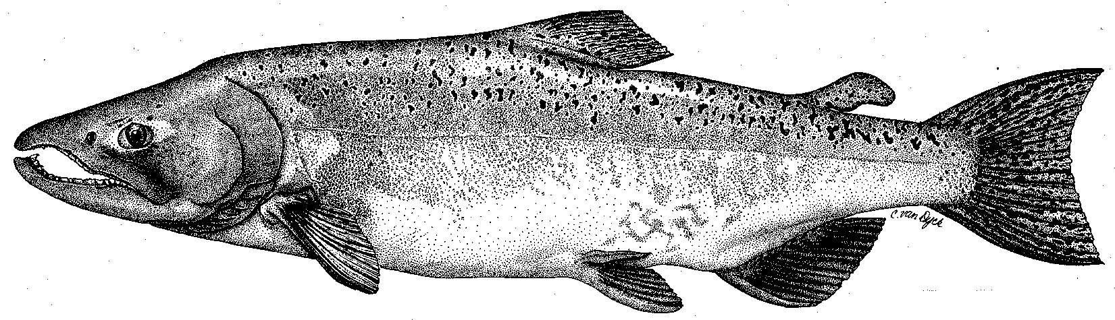

Turlock Irrigation District
City & County of San Francisco
California Department of Fish & Game
U. S. Fish & Wildlife Service
333 East Canal Drive
Turlock, CA 95381-0949
Phone: (209) 883-8275
Fax: (209) 656-2180
Email: tjford@tid.org

TECHNICAL ADVISORY COMMITTEE
MEETING MINUTES of
24 June 2003

1. AGENDA & PRIOR MINUTES
A. Comments were received on the draft 19 March 2003 meeting minutes.

2. ACTION ITEMS:
Decisions on the flow schedule for the remainder of the summer will be made under Item 3D, River Operations & Flow Schedules.

- GENERAL INFORMATION:
A. 1) Project GIS system has been converted to autoCAD format from the arcView format. This should help with scaling issues, but it is not in a web based viewing system. The ACOE Tuolumne River flood data is on a 2ft DTM, but is not available much above Modesto. The ACOE data is not incorporated into the Districts’ GIS data.

2) There was discussion on pulse flow studies in the basin and how the California Bay-Delta Authority (CBDA) staff like the way the TRTAC subgroup managed the CWT studies as a model for others to follow. Noah Hume of Stillwater indicated there was a proposal to model the pulse flow through at least the ship channel. A key issue is the mixing of Tuolumne flows with the San Joaquin flows and how to incorporate peer review. FOTT and DFG were concerned with timing of the fall pulse flow in attracting fish early through the delta when the conditions were not as favorable than if the fish came through later. USFWS is concerned with the water accounting true up process and how the water would be budgeted for salmon vs. steelhead. Noah indicated temperature and water quality issues were relatively easy to model, but straying and arrival time were difficult to quantify. The fall pulse flow plans will be reviewed at the Subgroup meeting in August.

B. AGENCY – NGO Updates
1) DFG: The Rotary Screw Trap (RST) was run into June. The redd count report is not completed (in August?) and the RST reports are being worked on. They hope to have the RST reports done in July.
2) TRPT: The conceptual plan for opening up berms on the south side of the Big Bend site is underway to be followed by the CEQA – NEPA permitting process. The TRPT did sign onto a brief supporting NMFS petition to FERC requesting consultation for the current steelhead issues. The TRC is studying other types of entity (legal status) they could become and developing a vision document as part of their public outreach process. The TRC is looking for more assistance from TID & MID on lobbying other agencies.
3) FOTT: The Attorney General flight and meeting were successful. The Grayson River Ranch revegetation maintenance – irrigation work was extended 1 year. The conceptual plan for the RM 43 and larger Bobcat Flat Projects are progressing through CBDA.
4) NOAA Fisheries: FERC will be asking the Districts to set up monitoring for steelhead as part of a NMFS – FERC process on steelhead and the settlement agreement.
5) USFWS: Comments on the draft Adaptive Management Forum Report are due by the End of Day Friday, 27 June 2003.

- Monitoring:
1) Snorkel results show the number of rainbow trout is up from the numbers found in 2002. The distribution down to the Turlock Lake State Recreation area is the same as in recent years. There will be supplemental snorkeling on 2 July as an adjunct to the normal areas covered.
2) Thermographs will be downloaded in July.
3) The RST operated through the first week in June, but the numbers were quite low by that time. The numbers of fish caught went up when the flows went up in late May.
4) Hume stated that the redd excavation/emergence study report could be ready by the SEP meeting.

- River Operations & Flow Schedule
1) The annual flows (including spring VAMP and summer flows) are developed using the Basin Index runoff values starting in April. There can be significant changes in the forecasted index between April and the final values in August. The Basin Index used for flow volume has been based on the 50% probability for the runoff.

Typically the summer flow is set at a constant rate. NOAA Fisheries and USFWS asked if temperature considerations could be incorporated into the release schedule without triggering any stranding if the flow rate did vary. FOTT asked that recreational boating flows of over 180 cfs be provided if possible. Data on typical summer temperature fluctuations for both air and water were presented. Starting with an estimated average flow of 205 cfs, the following flow adjustment regime was developed with the goal of maintaining a more constant reach of cooler water consistent with changes in air temperature. An example of the concept was shown using 2002 flows and air temperatures.
A) If the projected air temperature is 95 or less, then the river flow would be 195cfs.
B) If the projected air temperature is 96 or more, then the river flow would be 235 cfs. The higher flow would be carried 1 day past when the temperature drops below 96.

This flow regime will be reassessed after the final Basin Index comes out after July. The fall pulse flow and fall/winter flows will be adjusted accordingly. The thermograph data will be evaluated to see if this flow adjustment was effective.

E. Restoration Update:
1) DFG will be placing 15,000 CY of aggregate in the river upstream of the old La Grange Bridge and may be reshaping materials previously placed near the J59 Bridge. The gravel mix will be adjusted to be more accommodating for steelhead sized spawning aggregate needs.
2) A TRTAC project update report was distributed. Based of the status of the amendments before CBDA, it is possible that the MJ Ruddy project construction will not be started this summer.

4. ADDITIONAL ITEMS:
None

5. NEXT MEETING & TOPICS:
The next meeting will be 25 September 2003 starting at 0930.

FERC 2299 TAC Meeting

24 June 03

Name Organization

Tim Ford TID/MID

Wilton Fryer TID

Patrick Koepele TRPT

Jeff McLain USFWS

Allison Boucher FOTT

Ron Yoshiyama CCSF

John Chester CCSF

Noah Hume Stillwater Sciences

Tim Heyne DFG

Madelyn Martinez NMFS

Erin Strange NMFS

Roger Masuda TID

Jim Koontz TID

