Tuolumne River Technical Advisory Committee
Don Pedro Project - FERC License 2299

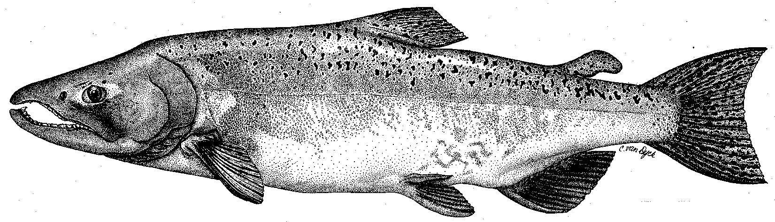

Modesto Irrigation District
Turlock Irrigation District
City & County of San Francisco
California Department of Fish & Game
U. S. Fish & Wildlife Service
333 East Canal Drive
Turlock, CA 95381-0949
Phone: (209) 883-8278
Fax: (209) 656-2191
Email: pemaloney@tid.org

TECHNICAL ADVISORY COMMITTEE MEETING
September 11, 2014 at 9:30 AM
Turlock Irrigation District, Room 152

DRAFT AGENDA

1. Introduction and Announcements

2. Administrative Items:

Review/revise agenda

Approve notes from June 2014 meeting

Items since last meeting

3. Monitoring/Reports:
- Routine snorkel and temperature
- In-progress FERC relicensing studies
- Fall monitoring 2014
- Planned Annual FERC Report progress

4. Flow Operations:
- Review status of final basin index; annual fish flow volume
- Fall flow schedule

5. Agency/NGO updates

6. Additional items

7. Next meeting Date – December 11

