Tuolumne River Technical Advisory Committee
Don Pedro Project - FERC License 2299

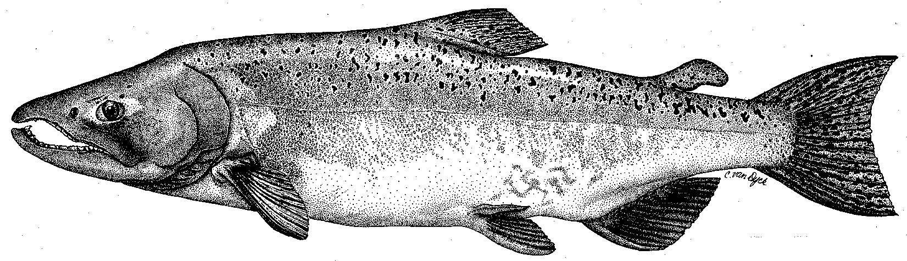

Modesto Irrigation District
Turlock Irrigation District
City & County of San Francisco
California Department of Fish & Game
U. S. Fish & Wildlife Service
333 East Canal Drive
Turlock, CA 95381-0949
Phone: (209) 883-8278
Fax: (209) 656-2191
Email: pemaloney@tid.org

TECHNICAL ADVISORY COMMITTEE MEETING
March 13, 2014 at 9:30 AM
Turlock Irrigation District, Room 152

DRAFT AGENDA

1. Introduction and Announcements

2. Administrative Items:

Review/revise agenda

Approve notes from Dec 2013 meeting

Items since last meeting

3. Monitoring/Reports:
- Fall run information – weir; river surveys
- Ongoing monitoring – seine, screw trap, weir
- 2013 Annual Report to FERC

4. Flow Operations:
- Current watershed conditions, runoff and flow volume forecasts
- Spring flow schedule(s)

5. Agency/NGO updates
- USFWS Bobcat Flat habitat utilization surveys

6. Additional items

7. Next meeting Dates – June 12, September 11, December 11

