Tuolumne River Technical Advisory Committee
Don Pedro Project - FERC License 2299

Modesto Irrigation District
Turlock Irrigation District
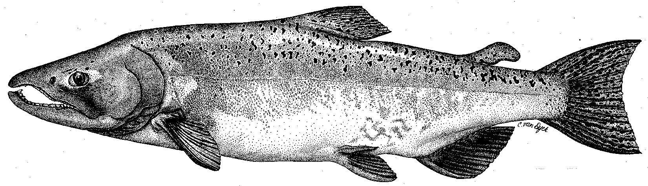

City & County of San Francisco
California Department of Fish & Game
U. S. Fish & Wildlife Service
333 East Canal Drive
Turlock, CA 95381-0949
Phone: (209) 883-8275
Fax: (209) 656-2180
Email: tjford@tid.org

TECHNICAL ADVISORY COMMITTEE MEETING
18 March 2010 at 9:30 AM
Turlock Irrigation District, Lunch Room (2nd floor)

Summary

1. Introduction and Announcements
- No fishery agencies were present.
- Jesse Roseman attended from TRT.

2. Administrative Items:

Review/Revise agenda – No changes

Review notes from 11DEC – Approved

Items produced since last meeting – reviewed the handout listing material posted at http://tuolumnerivertac.com/ Those included:

Prior meeting agenda, summary, and handouts

Correspondences regarding the January 15 O. mykiss monitoring report

January 15, 2010 report on O. mykiss pursuant to ordering paragraph (C)(5) of the April 3, 2008 FERC Order

Several technical reports for the annual FERC report

Counting weir data, seine data, and updates to the basin monitoring newsletter.

3. Monitoring/Reports:
- Salmon run data. Ford discussed salmon run estimates for the Tuolumne, Merced and Stanislaus Rivers and stated he was waiting for a 2009 spawning survey report from CDFG. Although CDFG reported 124 for the Tuolumne in GrandTab (excluding spawners below Fox Grove?), counting weir numbers were 280 by mid-January, and reached 300 by the week of March 15. By comparison, CDFG reported a GrandTab Stanislaus estimate of 595 while the weir count there was 1250 by mid-January; a handout of the daily weir counts was reviewed. Other GrandTab numbers were: Merced River with 604 (358:246 for River:Hatchery) and Mokelumne River with 2,229 (680:1549 for River:Hatchery).
- Counting weir. The weir will continue operation into April and May as flows allow (upper limit may be about 1500 cfs).
- Seine/Screw Trapping. Handouts of size and abundance of RST salmon catch were reviewed. At Waterford, the early fry peaks were associated with storm events, but catch was low at Grayson overall. Many larger juveniles (80-120 mm) were also caught at Waterford in January – those were not from fall 2009 run. The fall 2009 cohort catch began to include parr and smolts (50-80 mm) mainly in March at Waterford.
- O. mykiss Studies. Hume indicated that the March 2009 population estimate was complete. Ford reported that the adult O. mykiss tracking study had been approved and that the project would be initiated within the week.

4. Flow Operations:
- Reviewed water year forecasting based on 1 MAR 10%, 50% and 90% exceedance estimates (see handouts). Still a wide range between the 50% and 90% levels. VAMP flows were planned from April 25 to May 25 (at Vernalis)
- Discussions with the fishery agencies about the use of 7000 AF for pulse flows, base flow, or carryover storage were ongoing at the time of the meeting.

5. Agency/NGO updates

TRT
  - Roseman discussed a Jeff Jardine article in the Modesto Bee about the removal of the Dennett Dam and pursuing funding sources.
  - Roseman discussed a Farmwater Toolbox forum on Thursday March 25, 2010 at the UC Cooperative Extension in Merced. Details and other resources can be found at: http://agwaterstewards.org/txp/Home/
  - Roseman discussed the second TRT “Paddle to the Sea” event from May 7 to June 5.

6. Additional items
- None.

7. Next meeting dates – June 10, September 9, December 9

TRTAC Meeting Attendees

Name Organization
- Tim Ford TID/MID
- Noah Hume Stillwater
- Galileo Morales TID
- Robert Nees TID
- Jesse Roseman TRT
- Walter Ward MID

