Tuolumne River Technical Advisory Committee
Don Pedro Project - FERC License 2299

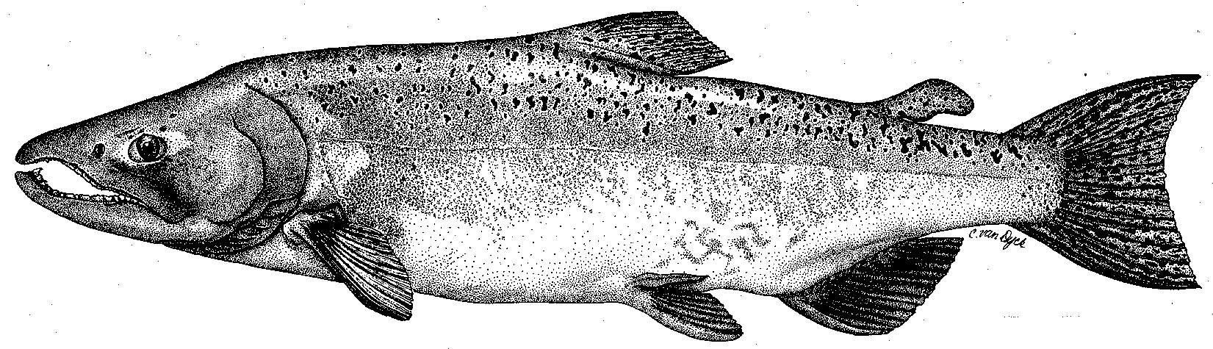

Modesto Irrigation District
Turlock Irrigation District
City & County of San Francisco
California Department of Fish & Game
U. S. Fish & Wildlife Service
333 East Canal Drive
Turlock, CA 95381-0949
Phone: (209) 883-8275
Fax: (209) 656-2180
Email: tjford@tid.org

TECHNICAL ADVISORY COMMITTEE MEETING
March 18, 2010 at 9:30 AM
Turlock Irrigation District, Lunch Room (2nd floor)

DRAFT AGENDA

1. Introduction and Announcements

2. Administrative Items:

Review/revise agenda

Approve notes from Dec 2009 meeting

Items since last meeting

3. Monitoring/Reports:
- Fall run information – weir; river surveys
- Ongoing monitoring – seine, screw trap, weir, winter snorkel survey
- 2009 annual FERC report
- Other planned studies for 2010

4. Flow Operations:
- Current watershed conditions, runoff and flow volume forecasts
- VAMP and potential spring flow schedule(s)

5. Agency/NGO updates

6. Additional items

7. Next meeting Dates – June 10, September 9, December 9

