Tuolumne River Technical Advisory Committee
Don Pedro Project - FERC License 2299

Modesto Irrigation District
Turlock Irrigation District
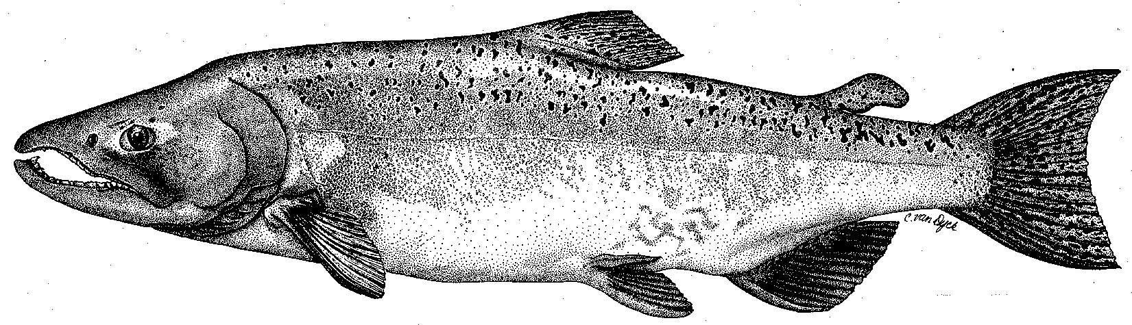

City & County of San Francisco
California Department of Fish & Game
U. S. Fish & Wildlife Service
333 East Canal Drive
Turlock, CA 95381-0949
Phone: (209) 883-8275
Fax: (209) 656-2180
Email: tjford@tid.org

TECHNICAL ADVISORY COMMITTEE MEETING
June 10, 2010 at 9:30 AM
Turlock Irrigation District, Room 152 (1st floor)

Summary

1. Introduction and Announcements
- No fishery agencies were present.

2. Administrative Items:

Review/revise agenda – no changes

Review notes from March meeting – no changes were identified

Items since last meeting – the handout listing the material posted at http://tuolumnerivertac.com/ was reviewed. Those included the annual report to FERC, 2009 spawning survey update, 2009 counting weir report, FERC Orders partially approving O. mykiss synthesis report and study plans for IFIM and water temperature, flow schedule and study planning letters to fishery agencies (6/28 reply deadline for comments on updated study schedules).

3. Monitoring/Reports: Handouts were reviewed
- May FERC Orders on planned studies: Ward asked for details on FERC Order requirements. For the May 10, 2010 Order: 1) Population estimates will continue to be conducted in July of each yr., with reference count surveys in June, September, and Feb/Mar (or as modified due to high flows), depending on accessibility due to flow conditions. 2) Tracking study to continue, 3) Annual O. mykiss reports by mid-January the next two years with a summary 2005–2012 fisheries report due by July 1, 2013. For the May 12, 2010 Order: 1) FERC delay resulted in a one year slippage in IFIM data collection, 2) Planned Agency Consultation in August/September, 3) possible Fall Pulse Flow test in October, but most of study expected next year, 4) Water temperature modeling to proceed this year
- Counting Weir: No longer in operation (upper flow limit was found to be 1,300 cfs). Final 2009 estimate through mid-January was 300 Chinook salmon spawners with 280 counted passing the weir and another estimated 20 downstream of the weir. CDFG carcass survey estimate was 124.
- Screw Trapping: Handouts on catch and size at Waterford and Grayson screw trap sites were reviewed. Catches were characteristically low at Grayson relative to Waterford and mainly only smolts in May; peak catches were associated with turbid conditions in January and March as well as high flows occurring in May as variable spring pulse flows. Some larger salmon from 70-130 mm were also caught in Jan-Feb.
- Seining size and catch data was reviewed. Peak fry densities occurred in Feb/Mar with lower densities near the end of the season.
- O. mykiss pop. estimate: Stillwater completed their March survey, with a preliminary report including both the March and July surveys to be completed later this year. If flow conditions allow, an August 2010 survey will be conducted.
- O. mykiss tracking study: Six larger fish have been tagged which have been recorded using the mobile hydrophone within 10 river miles of La Grange Dam.

4. Flow Operations:
- The SJ Basin Index forecast range resulted in a corresponding FERC flow volume requirement of 300,923 AF.
- Don Pedro Reservoir is within 5 ft of capacity and river operations include expected high flows of 2,000–3,000 cfs into July. Discussion of timing a possible 1,300 cfs maximum Fall pulse flow and fall spawning flows of 300 cfs.
- Basin flows and delta CVP/SWP exports graphs were reviewed. Vernalis flows during VAMP were mostly 4,000-6,000 cfs, but exports, which were reduced earlier than before on April 1, increased sharply in late May from 1,500 cfs to 7,000 cfs.

5. Agency/NGO updates
- None

6. Additional items
- None

7. Next mtg dates – Quarterly on 2nd Thursday: SEPTEMBER 9, DECEMBER 9

TRTAC Meeting Attendees

Name Organization

- Tim Ford TID/MID
- Robert Nees TID
- Roger Masuda TID
- Walter Ward MID
- Noah Hume Stillwater Sciences
- Scott Wilcox Stillwater Sciences

