Tuolumne River Technical Advisory Committee
Don Pedro Project - FERC License 2299

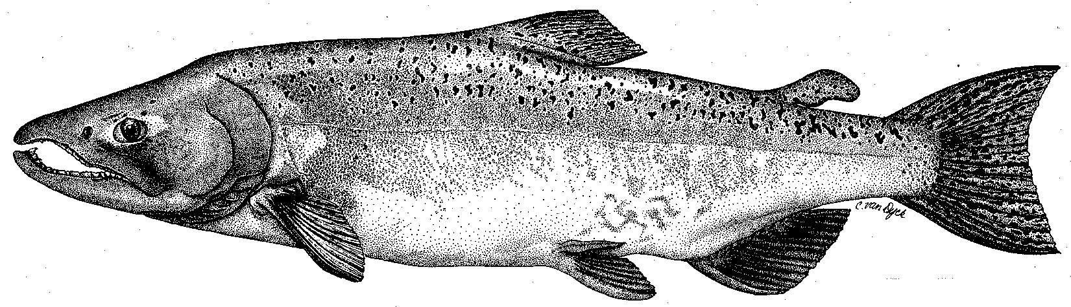

Modesto Irrigation District
Turlock Irrigation District
City & County of San Francisco
California Department of Fish & Game
U. S. Fish & Wildlife Service
333 East Canal Drive
Turlock, CA 95381-0949
Phone: (209) 883-8275
Fax: (209) 656-2180
Email: tjford@tid.org

TECHNICAL ADVISORY COMMITTEE MEETING

09 February 2006
9:00 AM
Turlock Irrigation District, Lunch Room (2nd floor)

Draft Meeting Summary

1. Introduction
- Comments on draft agenda and meeting summary – no comments; 09:30 AM was set for start of all TRTAC meetings at TID or MID.

2. Items since 08Dec meeting

Review material list – Ford provided handout of list for all of 2005

Report on 14 Dec Monitoring PSP working group meeting – 07Dec (previously e-mailed) and 14Dec meeting summaries by Vick were handouts

Current status of CALFED PSP and gravel addition monitoring plans –

Vick provided a review of the status of the PSP (see also Dec meeting notes); Task 5 monitoring has been moved to the gravel addition project; Angling survey to include natural tagging approach using photos

Action: draft workplans will be provided by Vick/Hume by the Mar meeting; final to DFG in April with plan for 01Jul start of contract
- Long-awaited comments from CALFED on Coarse Sediment and Warner/Deardorf projects are being reviewed by Fryer
- Marked rocks could only be placed at Bobcat Flat before flows came up in Dec.

3. Discussion of monitoring; gravel placement sites –
  - Handout of 29Mar2005 memo from Mierau (previously e-mailed) on gravel addition sites was reviewed.
  - CDFG plans to add some gravel (2000 yards) this year above New La Grange Bridge (R1A-R1C reach). It was concluded that permitting issues would likely preclude any TRTAC gravel additions until 2007.
  - Action: Ford will review previous gravel addition recommendations to compare with current list.
  - Snorkel monitoring may begin in July under PSP program.

4. General Update

Data and report status –

Handout on items for annual report was reviewed and draft deadlines were chosen for all elements – revised table reflecting the discussion is at end of this summary; final submittal date remains at 01 April. Plan is to include 2004 and 2005 TRTAC materials and Ford will try to distribute a draft of summary section (and component reports) for review.

Action: (1) assigned parties will work to meet specified timelines; Ford to check with Blakeman on data needs
- Agency and NGO updates –
  - AFRP will have more short-term moves in Lodi offices; Mesick reported he is still working on conceptual models
  - Hume reported that Peter Baker of SWS would not be available this spring
  - Boucher reported planting at Bobcat flat is planned for March; flow enters high flow channel at ~3000 cfs.
  - Koepele reported that TRPT has a new exec. Director; planting is continuing at Big Bend

Monitoring update –
  - Handout on initial RST results at 2 trap locations from Fuller (e-mail of 08Feb)
  - Handout of long-term basin run estimate graph from Ford using early estimates of 3,500 Stan, 800 Tuol, and 2,900 Merced for 2005
  - Seining has found salmon throughout Tuolumne and into SJR.
  - A predation study at SRP 9 is scheduled to occur this spring

River operations and forecasts –

Maintaining current operations is expected in near-term. Those are flows of 2500-3000 at La Grange, with 400 cfs to Hickman Spill. Flow is varying somewhat, partly as a result of testing phase of new TID power plant, but use of TID canal is limiting changes; intermittent MID spill to Dry Creek.

Projected flow range in Apr-May period is 1000 (dry) to 5000 (wet) at this early stage.

Monier is preparing the annual letter reviewing the fall pulse flow and 45-day period.

4. Additional items –
- Ford reviewed discussion topics selected at Sep2005 meeting and which meetings they had been discussed
- Districts are pursuing website for TRTAC
- No news regarding FERC process
- VAMP barrier is undecided due to delta smelt issues even if flows would allow installation

5. Next meetings and topics:
- 09Mar at TID, 9:30 AM – website, flow experiments, conceptual models, monitoring
- Subgroup on 06Apr at MID, 9:30 AM – conceptual models

FERC 2299 TRTAC Meeting

09 February 2006

Name Organization

Tim Ford TID/MID
Robert Nees TID
Bill Johnston MID
Ron Yoshiyama CCSF
Patrick Koepele TRT
Allison Boucher FOT
Tim Heyne DFG
Dennis Blakeman DFG
Carl Mesick FWS-AFRP
Jeff McLain (phone) NMFS
Noah Hume Stillwater Sciences
Jen Vick McBain & Trush

Revised table resulting from meeting discussion

