Tuolumne River Technical Advisory Committee
Don Pedro Project - FERC License 2299

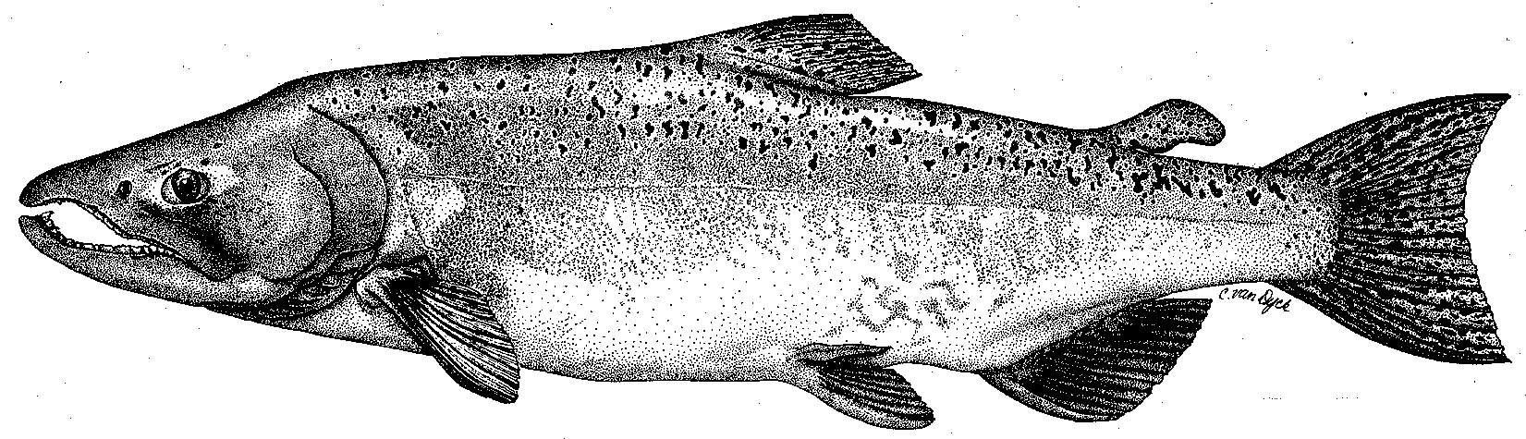

Modesto Irrigation District
Turlock Irrigation District
City & County of San Francisco
California Department of Fish & Game
U. S. Fish & Wildlife Service
333 East Canal Drive
Turlock, CA 95381-0949
Phone: (209) 883-8275
Fax: (209) 656-2180
Email: tjford@tid.org

TECHNICAL ADVISORY COMMITTEE MEETING

09 February 2006
9:00 AM
Turlock Irrigation District, Lunch Room (2nd floor)

DRAFT AGENDA

1. Introduction
- Comments on draft agenda and meeting summary

2. Items since 08Dec meeting

Review material list

Report on 14 Dec Monitoring PSP working group meeting

Current status of CALFED PSP and gravel addition monitoring plans
3. Discussion of monitoring; gravel placement sites
4. General Update

Data and report status
- Agency and NGO updates
- Monitoring update

River operations and forecasts
4. Additional items
5. Next meeting and topics

