Tuolumne River Technical Advisory Committee
Don Pedro Project - FERC License 2299

Modesto Irrigation District
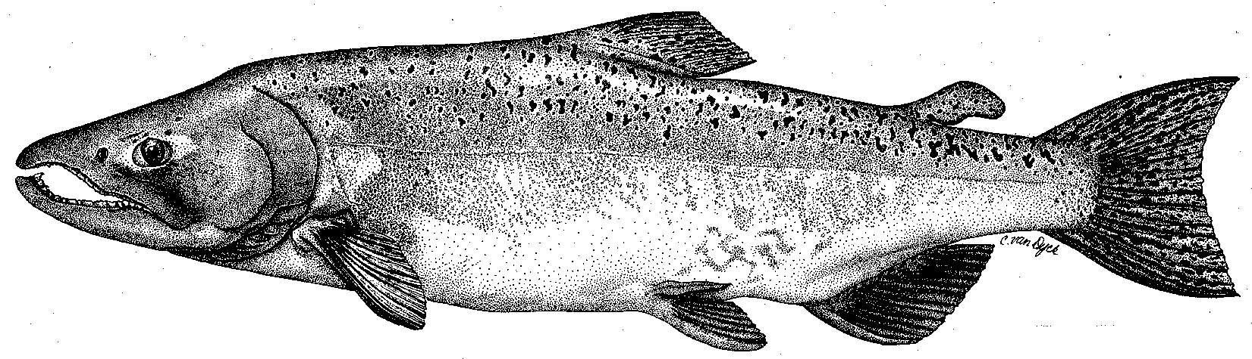

Turlock Irrigation District
City & County of San Francisco
California Department of Fish & Game
U. S. Fish & Wildlife Service
333 East Canal Drive
Turlock, CA 95381-0949
Phone: (209) 883-8275
Fax: (209) 656-2180
Email: tjford@tid.org

TECHNICAL ADVISORY COMMITTEE
MEETING MINUTES of
17 December 2003
DRAFT #1

1. AGENDA & PRIOR MINUTES
- The agenda was accepted as proposed. The minutes for the meeting of 25 September 2003 had been sent by email with the agenda. No comments were received regarding the minutes. Ligon, Gaedeke, and Bevelheimer joined the meeting by phone.
- The correspondence list since the last TRTAC meeting was presented by Ford.

2. ACTION ITEMS:
- The information filed with FERC on 1 December was the rainbow trout information available to the Districts. It was acknowledged that there are data gaps that could be filled. Tim Heyne of DFG reported that the genetic study by Jennifer Nielson may be completed and he would distribute it when available. The trout otoliths are with Chris Zimmerman in Alaska as part of a valley-wide study being conducted. He indicated the trout scales were with Brian Beale in Visalia (Region 4 Wild Trout biologist) and there was no priority to get them analyzed. Any other data should be provided for complete summary.
- Potential tasks to be included in the 2004 Monitoring Program, with particular emphasis on trout:
  - There was discussion on the difficulty in conducting spawning surveys for steelhead compared to the current effort for salmon. Walser indicated the survey period could be extended into May. Redds are smaller, more difficult to see and the fish are fewer and more wary than salmon, making counting difficult. There was further discussion on the need to agree on what constituted steelhead spawning habitat, particularly related to future riffle reconstruction projects. 2004 could have reconnaissance surveys for typical habitat features and a subsequent surveys to better detail those habitat areas. Heyne proposed consideration of a more intensive approach using a North Coast method that he would provide. He further suggested that approach could take a year or two to develop a study approach. He was also concerned about DFG staffing any survey work. He did confirm that DFG had no winter survey data. Martinez will provide American River survey methods. Mesick/Walser will ID sites on the habitat maps.
  - There was discussion on the status of the current temperature model and the interest in moving to a daily time step and incorporating additional thermograph data. Hume will provide an estimate of the cost of model update. The discussion included DO monitoring and it should be considered. There was some brief discussion of trout temperature ranges in the December submittal to FERC. There was discussion on the issue of how to consider impacts due to conditions in the Delta as it affected the survival of both salmon and steelhead.
  - Martinez suggested one or more snorkel surveys be done between the current June and September surveys.
  - Martinez requested monitoring plans in January, as a permit for some monitoring may need to be expedited.

- GENERAL INFORMATION:
- Tim Ford went over the FSA program expenses to date. The use of the contingency funds for completing the earthwork on the 7\11 Project pushed the FSA funds significantly higher for the year, leaving about $100,000 for non-flow measures. There is only about $80,000 estimated remaining for monitoring.
- Other updates: The next CBDA PSP will focus on monitoring and this could be problematic for obtaining construction funds for next phases of projects that are designed and permitted on the Tuolumne River. FERC decision on petition will be posted in 2-3 days.
- Monitoring (not covered under the Item 2 monitoring discussion):
The status of the current year spawning survey was not available from DFG. The monitoring subgroup may resume working on the monitoring “umbrella document” to combine river wide and project specific monitoring.
- River Operations were not discussed, as there is no planned changes in the current flow schedule.
- Restoration Project Update:
  - Wilton distributed a summary sheet indicating the status of the TRTAC sponsored restoration projects. Wilton requested TRTAC approval to proceed with an amendment to the La Grange Gravel Acquisition and Sediment Transfusion project. Technical mining permit and aggregate acquisition issues, combined with protests by adjacent neighbors and a Grand Jury inquiry into how the mining and acquisition portion of the project was formulated and presented to the public will make the mining and acquisition portion of the project problematic. The amendment to go before the CBDA review panel would delete the mining and acquisition portion of the project and shift those funds to increasing the inchannel gravel placement portion of the project. There was discussion if another agency or NGO on the TRTAC would be able to takeover the project in its original form. It was agreed that the current controversy would remain regardless of who was managing the project. ACTION ITEM: Wilton was directed to proceed with the amendment submittal.
  - Carl Mesick and Steve Walser (California Rivers Restoration Fund) presented riffle design features for steelhead and monitoring for riffle restoration projects in the vicinity of Lovers Leap on the Stanislaus River. Handouts were distributed showing the use of GPS to map out velocity profiles over riffles and typical microhabitat features the steelhead seem to prefer, including aggregate sizes. Salmon and steelhead habitats were found to be in close proximity. There were questions as to what level of detail would be sufficient for laying out the basic design during reconstruction of riffles. Mesick presented information on the difficulties in conducting monitoring for steelhead and a proposal for sampling under a NOAA Fisheries Section 10 permit.

5. NEXT MEETING & TOPICS:
  - The next monitoring subgroup meeting will be 0930 to 1530 on Wednesday 28 January 2003 in Room 3A at MID. The meeting will further focus on steelhead.
  - The next TRTAC meeting will be 0930 to 1530 on Thursday 11 March 2003 at TID.

FERC 2299 TAC Meeting

17 Dec2003

Name Organization

Tim Ford TID/MID

Wilton Fryer TID

Darren Mierau M&T

Patrick Koepele TRPT

Jeff McLain USFWS

J.D. Wikert USFWS

Allison Boucher FOTT

Ron Yoshiyama CCSF

Noah Hume SWS

Tim Heyne DFG

Janiel Killen NOAA Fisheries

Madelyn Martinez NOAA Fisheries

Carl Mesick CRRF

Steve Walser CRRF

By phone:

Frank Ligon SWS

Mark Bevelhimer ORNL

Erich Gaedeke FERC

