Tuolumne River Technical Advisory Committee
Don Pedro Project - FERC License 2299

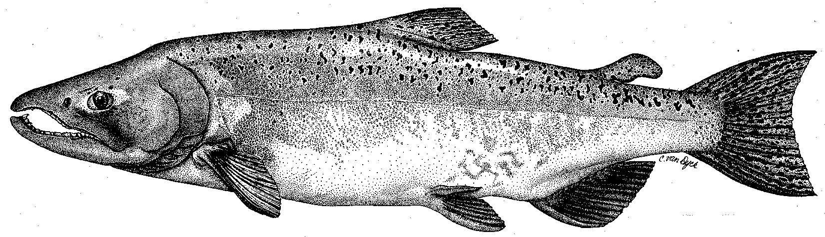

Modesto Irrigation District
Turlock Irrigation District
City & County of San Francisco
California Department of Fish & Game
U. S. Fish & Wildlife Service
333 East Canal Drive
Turlock, CA 95381-0949
Phone: (209) 883-8275
Fax: (209) 656-2180
Email: tjford@tid.org

TECHNICAL ADVISORY COMMITTEE MEETING

13 July, 2005, 10:00 a.m.
Turlock Irrigation District, Lunch Room (2nd floor)

Draft Meeting Summary

1. Introduction
- Comments on draft agenda
- Correspondence since last meeting: list was reviewed
2. Overview presentation of 2005 10-year report:
Considerable time was spent going through PowerPoint presentation by Hume and several specific comments/corrections were provided: on 3-34 remove TRT from Grayson project list, describe steelhead instream work for Bobcat Flat and add Waterford to list on 3-35; Districts can compile additional comments. Hume will confirm specifics of model on pg. 4-8.

3. General Update: Data and report status: DFG is gathering water temperature data for basin model; their Sportfish report may be complete in two months

Agency and NGO updates: McLain reported the green sturgeon final rule is expected next year – looking for evidence in SJR system, but not likely in Tuolumne; steelhead listing is delayed until end of year; spring run Chinook final rule was published recently. FOT reported that Waterford plantings look good – this will be first year without irrigation. Mesick requested any project ideas or requests as AFRP workplan is being updated. Walser stated that their biologist would be available this fall.

Monitoring update: DFG Mossdale sampling is complete and CWT data is being gathered; carcass surveys are unfunded

River operations and forecasts

Restoration: A status update from Fryer was handed out and discussed. CALFED is reviewing projects where funds have not been expended and that might create more delay. Part of Ruddy Project funding has been removed. RM43 project work is planned for about one month starting 22 August with lower flows – gravel to be added at six sites. DFG gravel work may proceed next year.
4. Additional items
5. Next meeting and topics:
21 Sep 2005 at 9:30 AM, TID

FERC 2299 TRTAC Meeting

13 July 2005

Name Organization

Tim Ford TID/MID
Robert Nees TID
Debbie Liebersbach TID
Roger Masuda TID
Bill Johnston MID
Donn Furman CCSF
John Chester CCSF
Ron Yoshiyama CCSF
Nicole Sandkulla BAWSCA
Allison Boucher FOT
Dave Boucher FOT
Patrick Koepele TRT
Jen Vick McBain&Trush
Noah Hume Stillwater Sciences
Dean Marston DFG
Dennis Blakeman DFG
Tim Heyne DFG
Carl Mesick FWS-AFRP
Jeff McLain NMFS
Steve Walser CRRF

